新 书 推 荐

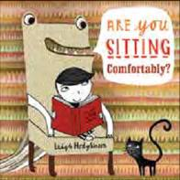
中文书名：《坐在这儿舒服吗》
英文书名：Are You Sitting Comfortably
作 者：Leigh Hodgkinson
出 版 社：Bloomsbury Children’s Books
代理公司：ANA
出版日期：2016年3月
代理地区：中国大陆、台湾
审读资料：电子稿/样书
页 数：32页
类 型：儿童绘本

卖点提炼：

- A delightfully packaged picture book that will excite and intrigue little ones, whilst being a highly desirable new addition to the book shelves of design-savvy grown-ups
- With striking tonal artwork complemented by beautifully rendered pattern and print, and a bold, confident design, this will have huge appeal for fans of Neal Layton, Alex T. Smith and Lauren Child
- Leigh Hodgkinson is the talent behind picture books such as Colin and the Snoozebox (Orchard), Goldilocks and Just the One Bear (Nosy Crow) and Don’t Dip Your Chips in Your Drink, Kate (Orchard) to name but a few. She is an award-winning animator who was art director on the
- BAFTA-award winning series, Charlie and Lola
- Are You Sitting Comfortably? is her first book for Bloomsbury

内容简介：

Join one small book lover’s quest to find the perfect snuggle-up-and-lose-yourself-in-a-book place in this playful celebration of sharing books and reading.

作者简介：

Leigh Hodkinson is an award-winning animator and worked as art director on the BAFTA-award winning animated series, Charlie and Lola. She is also an award-winning children's book author and illustrator, who is absolutely passionate about writing, making things up and daydreaming. Among her many brilliant picture books is Don't Dip Your Chips in Your Drink, Kate, written by Caryl Hart, which won Highly Commended in the 2010 Sheffield Children's Book Award, Picture Book Category. Leigh lives and works in Surrey and is married with a baby daughter.

内文图画：

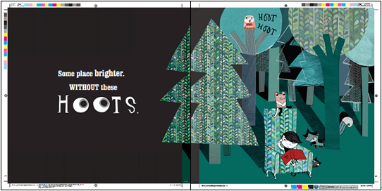

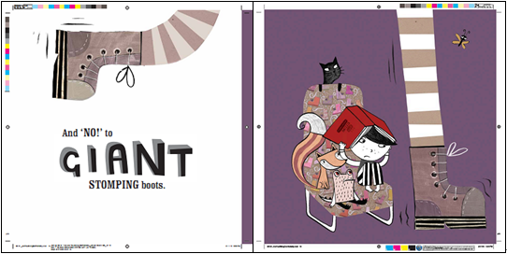

谢谢您的阅读！
请将回馈信息发至：宁非 (Katalin Ning)
安德鲁﹒纳伯格联合国际有限公司北京代表处
北京市海淀区中关村大街甲59号中国人民大学文化大厦1705室, 邮编：100872
电 话：010-82509406
传 真：010-82504200
Email：Katalin@nurnberg.com.cn
网 站：Http://www.nurnberg.com.cn
新浪微博：http://weibo.com/nurnberg
豆瓣小站：http://site.douban.com/110577/
微信订阅号：安德鲁书讯


