**新 书 推 荐**

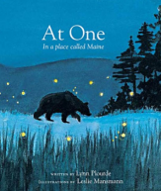**中文书名：《那美妙的一刻》**

**英文书名：*At One: In a place called Maine***

**作 者：Lynn Plourde**

**绘 者：Leslie Mansmann**

**出 版 社：Islandport Press**

**代理公司：Transatlantic Literary Agency Inc./ANA**

**出版日期：2007年**

**代理地区：中国大陆、台湾**

**审读资料：电子稿**

**页 数：34页**

**类 型：儿童绘本**

**内容简介：**

At One: In a Place called Maine is a love letter to the state of Maine, lyrically and graphically celebrating its inspirational beauty from the wilds of Baxter State Park to the crashing waves of the Atlantic. All of the scenes featured in At One were inspired by award-winning author Lynn Plourde’s experiences, including twin fawns who visited her backyard in Winthrop, a hike up Katahdin, cross-country skiing by moonlight, and an encounter with a bear while camping. At One is a classic Maine picture book.

**作者简介：**



**Lynn Plourde** is a native Mainer who frequently uses her home state as inspiration when writing about moose, the four seasons, Mount Katahdin, and being at one with nature. She lives in Winthrop, Maine, with her husband. She is the author of the children’s book, Merry Moosey Christmas, illustrated by Russ Cox.



**Leslie Ann** Windstein Mansmann has shared her talent of nature illustrations and commercial production for many years. She has published several children’s books and humor books as well as a myriad of educational publications.

**内文图画：**

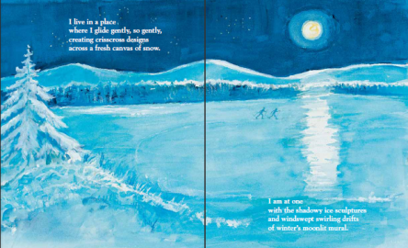

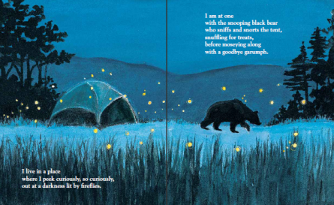

**谢谢您的阅读！**

**请将回馈信息发至：宁非(Katalin Ning)**

**安德鲁﹒纳伯格联合国际有限公司北京代表处**  
北京市海淀区中关村大街甲59号中国人民大学文化大厦1705室, 邮编：100872  
电 话：010-82449901

传 真：010-82504200  
Email：[Katalin@nurnberg.com.cn](mailto:Katalin@nurnberg.com.cn)

网 站：[Http://www.nurnberg.com.cn](http://www.nurnberg.com.cn/" \t "_blank)

新浪微博：http://weibo.com/nurnberg

豆瓣小站：[http://site.douban.com/110577/](http://site.douban.com/110577/" \t "_blank)

