**新 书 推 荐**

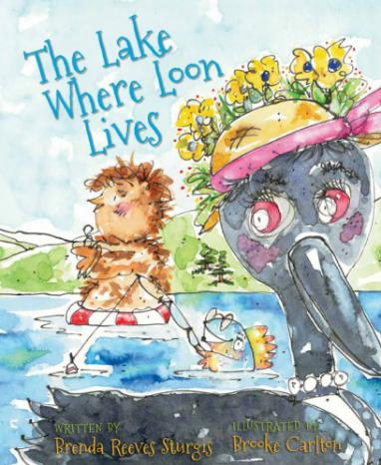**中文书名：《潜鸟湖》**

**英文书名：*The Lake Where Loon Lives***

**作 者：Brenda Reeves Sturgis**

**绘 者：Brooke Carlton**

**出 版 社：Islandport Press**

**代理公司：Transatlantic Literary Agency Inc./ANA**

**出版日期：2014年5月**

**代理地区：中国大陆、台湾**

**审读资料：电子稿**

**页 数：32页**

**类 型：儿童绘本**

**内容简介：**

There's a lake. With a loon. Two chicks. Sounds peaceful, right? Guess again!

The Lake Where Loon Lives starts quietly, but the cumulative story builds, one line at a time, to a wacky and wonderful and splashy crescendo, as the loons are joined by a playful fly, a slippery fish, and a curious boy on the dock.

Brenda Reeves Sturgis treats us to fanciful and evocative word play while Brooke Carlton's exuberant watercolors tell the story behind the story. Mama Loon rolls her eyes and tolerates the antics that take place on the lake until, at the end, she snuggles with her chicks who are ready for sleep, just as the readers of this wonderful picture book will be!

**媒体评价：**

"The narrative doesn't adhere strictly to the traditional rhyme scheme, giving it enough originality to keep it fresh and amusing. Carlton's delightful watercolor and pen-and-ink illustrations are perfectly matched to Sturgis's playful story. From the smallest of background details to extreme close-ups, the cartoon style and bright colors are sure to catch and hold young readers' attention."

----*School Library Journal*

“The Lake Where Loon Lives is a complete adaptation of the old story poem "This Is the House Where Jack Lives." Instead of Jack, the main character is a fearless, sedate Mama loon and her two baby chicks. The rest of the story concerns a fly, a fish, a boy, a lake, a struggle, and a peaceful resolution on a lovely, moonlit lake. Spectacular, original, wacky watercolor paintings fully express all the drama contained in The Lake Where Loon Lives. Whoever heard of annoying flies that practice a trumpet, or a Mama Loon who wears a flowered hat and has tea from a camp stove, or a pair of loon chicks who water ski? If you can imagine it, the loony pictures of The Lake Where Loon Lives will evoke it, hilariously! Exciting vocabulary melds with familiar verse patterns and tell the highly unlikely story filled with splashy adventures of The Lake Where Loon Lives. The scenery of rural Maine informs and pervades this charming book by two very talented, creative individuals."

----*Midwest Book Review*

"Filled with a energy that will capture readers’ attention from the get-go, this delightful story celebrates the cacophony of loons, mixing with chattering chicks, snapping fish and buzzing flies . . . An ode to summer and all things outdoor, this picturesque picture book pays tribute to the symphony of nature and all its wonderful sounds."

----*The Talking Walnut blog*

**作者简介：**

 

**Brenda Reeves Sturgis** a Maine author who began her writing journey in 2004. She is the author of 10 Turkeys in the Road and No Fun in the Sun for Santa. She and her husband Gary live on a lovely little lake where she listens to loons wail and watches an occasional moose meander across her back yard. She has four children and five grandchildren.

**Brooke Carlton**‘s whimsical illustrations have appeared in children’s magazine and book publications, private home collections, commercial brochures and posters, mailing envelopes, and even large mural walls. Brooke is also a musician. With paintbrush in one hand, saxophone in the other, and her dog, Lucy, at her feet, she works out of her tiny studio in the woods of rural Maine.

**内文图画：**

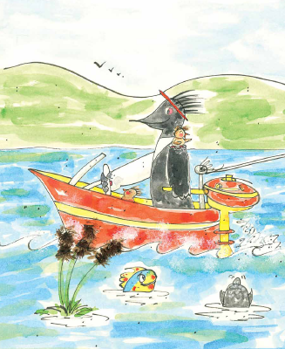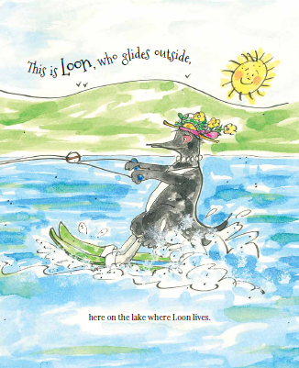

**谢谢您的阅读！**

**请将回馈信息发至：宁非(Katalin Ning)**

**安德鲁﹒纳伯格联合国际有限公司北京代表处**  
北京市海淀区中关村大街甲59号中国人民大学文化大厦1705室, 邮编：100872  
电 话：010-82449901

传 真：010-82504200  
Email：[Katalin@nurnberg.com.cn](mailto:Katalin@nurnberg.com.cn)

网 站：[Http://www.nurnberg.com.cn](http://www.nurnberg.com.cn/" \t "_blank)

新浪微博：http://weibo.com/nurnberg

豆瓣小站：[http://site.douban.com/110577/](http://site.douban.com/110577/" \t "_blank)

