新 书 推 荐
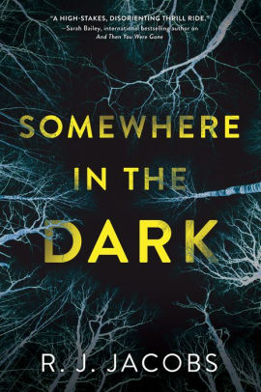
中文书名：《黑暗中的某处》
英文书名：SOMEWHERE IN THE DARK
作 者：R. J. Jacobs
出 版 社：Crooked Lane
代理公司：Biagi /ANA/Jessica Wu
页 数：336页
出版时间：2020年8月
代理地区：中国大陆、台湾
审读资料：电子稿
类 型：惊悚悬疑

内容简介：

Do the mistakes of the past mark us as guilty for life?

After a childhood marred by neglect, Jessie Duval's finally got it together. With an apartment in Nashville and a job with a catering company, she's thriving.

But all that changes when Jessie works an event where celebrities will be in attendance—including the one person from her past she must avoid at all costs: singer Shelly James. Jessie doesn't hate Shelly. Quite the opposite. One summer, she followed Shelly's tour everywhere. Only, Shelly wasn't flattered; she was terrified by Jessie's devotion—especially after Jessie was arrested. But after a year of therapy, Jessie understands what happened. She's not the same person anymore.

Jessie keeps her head down, but when Shelly is found dead, Jessie's troubled past comes tumbling out and she quickly becomes a suspect in the high-profile murder. As the police close in on her, ignoring other credible leads, Jessie realizes Shelly's murder will be pinned on her—the perfect scapegoat—unless she finds the real killer. And no one knows Shelly's life and inner circle better than her. But she will have to go deeper into the dark—if ever she wants to find her way out.

作者简介：

R. J. Jacobs lives in Nashville, where he maintains a private practice as a psychologist. Since completing his post-doctoral residency at Vanderbilt University, he has taught Abnormal Psychology, presented at numerous conferences, and routinely performs PTSD evaluations for veterans.

谢谢您的阅读！
请将反馈信息发至：吴伊裴（Jessica Wu）
安德鲁﹒纳伯格联合国际有限公司北京代表处
北京市海淀区中关村大街甲59号中国人民大学文化大厦1705室，100872
电 话：010-82449901
传 真：010-82504200
Email：Jessica@nurnberg.com.cn
Http://www.nurnberg.com.cn
新浪微博：http://weibo.com/nurnberg
豆瓣小站：http://site.douban.com/110577/

