新 书 推 荐
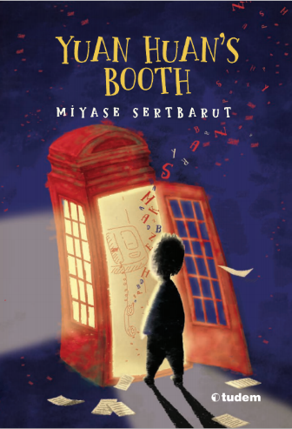
中文书名：《袁涣的故事电话亭》
英文书名：YUAN HUAN’S TELEPHONE BOX
作 者：Miyase Sertbarut and Zulal Ozturk
出 版 社：Tudem Publishing
代理公司：Black Cat Agency/ANA/Emily Xu
页 数：136页
出版时间：2019年
代理地区：中国大陆、台湾
审读资料：电子稿
类 型：9-12岁少年文学
版权已授：韩国、意大利、阿拉伯、阿尔巴尼亚
Selected for IBBY 2022 Honour List

作者Miyase Sertbarut 最新获得2024年安徒生奖提名，曾获得2016年林格伦奖提名

内容简介：

国际安徒生奖提名、林格伦奖提名作家创造的奇妙故事盒子
“我们的世界是最伟大的故事，并将一直被书写下去”。

人工智能不会拒绝文学，只要文学不排斥人工智能。一本神秘的桥梁书，五个相互关联的故事，引发孩子们对文学和科技关系的思考。

故事的主角拉米觉得阅读是一件很无聊的事，有一天他无意中发现了一个旧的红色电话亭，起初他进入电话亭知识为了好玩，可当他拿起听筒时，他被电话中传来的奇妙故事深深迷住了。很快，拉米沉浸在这些故事当中，同时他也想到一个妙用：用这些听来的故事来交阅读写作课的作业！为了让老师和同学们感到信服，他谎称自己是从一位中国作家的书中读到的这些故事。这些故事真的很精彩，每一节课老师都给他打了100分满分。对于不爱读书的拉米来说，能如此轻巧地获得高分，一切看起来都好极了！

但拉米也被心中的疑团所困惑，他一直觉得自己只是在听一段段录音，可是电话里的声音到底是提前录好的，还是有真人在背后呢？那位叫作袁涣的中国作家真的存在吗？拉米的脑子乱做一团。

随着他听的故事越来越深入，这个红色电话亭也引领他发现了更多关于人工智能的奥秘。而通过对真相的不断追寻与探索，拉米也从这位中国作家的故事中逐渐发现了自己对阅读的热爱。

主要卖点：

- 《袁涣的故事电话亭》将文学与科学技术相融，科技不仅可以迅速改变我们的生活，也能引发我们对其的批判性阅读与思考。
- 《袁涣的故事电话亭》中的角色对小说中讲述的故事进行了批评与评价。有时，那些角色甚至会对书的故事或结尾进行细微的修改。
- 本书结合了地域特色和普遍共性；也同时提供了是传统的以及数字的叙述者。虽然《袁涣的故事电话亭》中的几个奇迹故事是相互关联的，但书的本身也带来了奇迹。在故事的结尾，拉米已经不再是我们最初认识的那个不爱读书的拉米了。书具有如此强大的力量，它可以将人们卷入故事的神奇世界，甚至是那些不愿意阅读的人。而在书中，这不仅是一种神秘的力量，也更是一种科学技术的力量。
- 《袁涣的故事电话亭》向不喜欢阅读的读者们介绍了神奇的故事世界。不是什么神秘的东西，而是技术和故事相结合的魔力。

作者简介：

米娅兹·塞特巴鲁特（Miyase Sertbarut）1963年出生于杰伊汉，1985年毕业于土耳其加齐大学教育系。她曾在不同年龄段的学校教学，因撰写广播剧本闻名。在出版了第一本书并获得了土耳其儿童故事大赛一等奖之后，她开始专注于儿童书籍的创作。她已经出版了近30本儿童书作品，获得过十几个荣誉奖项，并在2016年获得了林格伦奖提名。她也最新获得2024年安徒生奖提名。

内文插图：
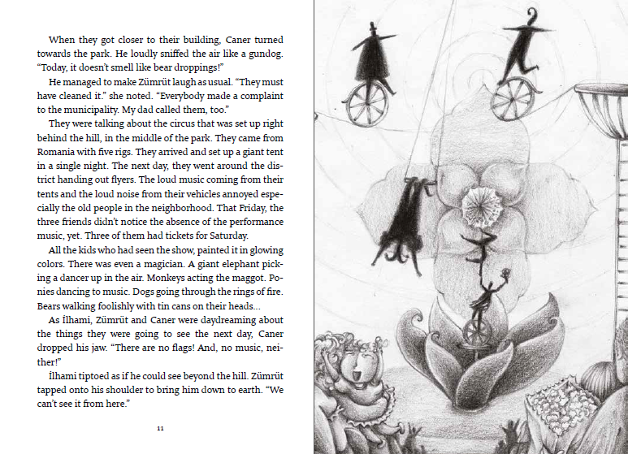
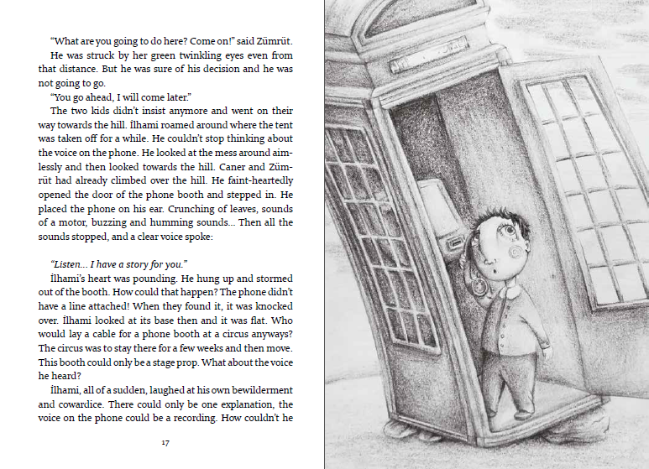
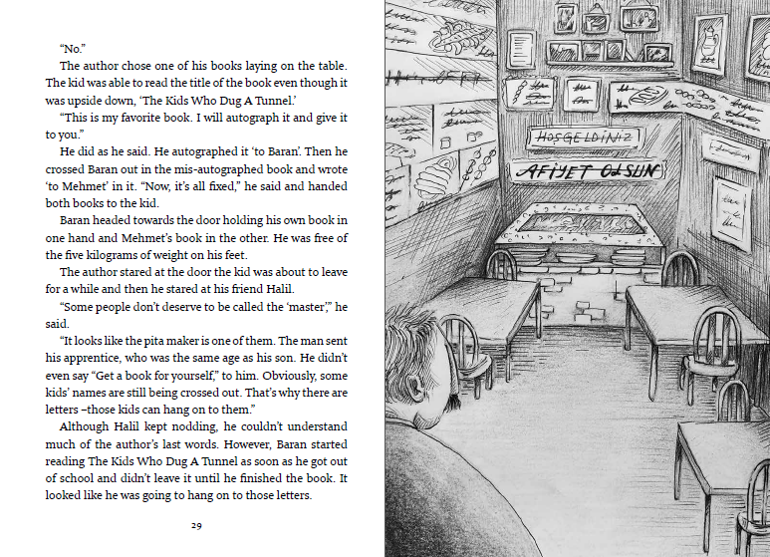
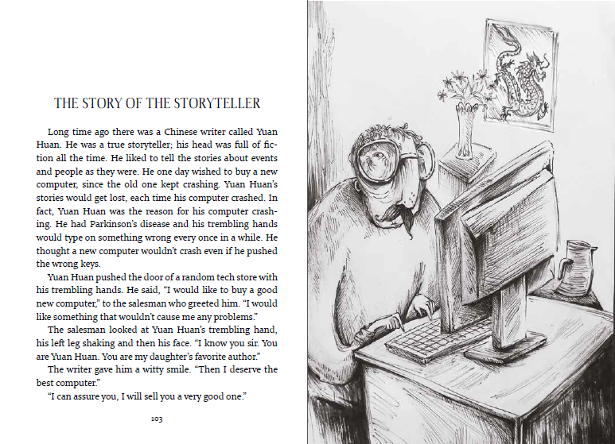

作者采访：

What is the main theme of the book in one sentence for you?
Stories are immortal and retain their freshness even if the transmission methods change from time to time. Maintaining the existence in future is one of the main goals of the authors.

What was your main starting point while writing your book? Why did you write this book?
İt will be a weird answer a little bit but my starting point was my lack of time. There were so many school invitations that I couldn’t find time to write. There is one sentence in Yuan Huan’s Booth that says, “Time expands if one wishes.” So adopting this as a principle, I thought, “How can I expand time?” and eventually this formula came to my mind. I could combine the metafiction with the stories I could write in tight times. This formula both expanded my time and led to the emergence of a solid narrative.

What are the features that can be highlighted regarding the content and technique of the book?
I like doing patchwork with fabrics.
I can’t do it well, but I still like it. For me, this book was like a patchwork made of stories. I guess I managed what I couldn’t do with fabrics in this novel. There are five stories in the book and of course there is a metafiction that connects them with each other. The narrator of the stories, a Chinese writer from far away, gets in touch with a child and starts to tell the situation of some children in Turkey with stories to the main character, İlhami. In these stories, there are working children, children in prison, brave children, and those who want to go to school but cannot.
In education system, there is a principle called “from the simple to the complex”, that is, from easy to difficult. The habit of reading and the love of books are also given to the child by this method. While Yuan Huan’s Booth first proceeds as if it were a series of normal stories, towards the end, the reader begins to feel the confusion whether Yuan Huan is real or not. The excitement and pleasure of the mysterious world of reading begins when this confusion appears. Thus, the reader easily transitions to the depths of literature, as if he/she were leveling up in a book he had started to read elementarily.

What are the distinguishing features of your book from the other books that are published in the same field?
This is a book that can encourage children to read critically. For example, in Yuan Huan’s first story, The Crossed-Out Kids, it is not clear who crossed out the writings in the pâtisserie, and İlhami, who listens to the story, reflects on it. What goes through the mind of İlhami will also guide the reader. Seriously, who crossed out the writing in the pâtisserie? The story is open to be completed and to be concluded by someone else. In order not to leave the reader in too much dark, three options are offered. Those writings were drawn by either Baran, the author or the letters themselves. For the ending of the fiction, the readers will inevitably find themselves in the position where they can build onto the story with one of these three options. I believe that the reader should be as active as the writer. Critical reading also requires this, that is, the reader is not the external element, but the internal element. Yuan Huan’s Booth contains many question marks that will keep the reader active. The main character İlhami, and his classmates sometimes guide the reader as practitioners of the critical reading technique.

Where does the name Yuan Huan come from?
“While writing this book, I wanted the character (the storyteller) to be someone from a far country. Thus the distance would excite the reader (and me) and show that stories have the power to bring people closer with each other no matter where they are in the world. The image of China in Turkey has connotations with distance, so I chose China. When I was searching for the character’s name, I thought I should name it after a Chinese who really lived. As a result of internet searches, I came across the melodious name of Yuan Huan, a government official who lived in the 200s BC. He had various services in the Eastern Han Dynasty and he mentored Commander Cao Cao. He was a loved one; so much so that the people believed that even Cao Cao cried after his death.While Cao Cao is portrayed in the literature as a ruthless tyrant, I was also struck by his humanization in the face of Yuan Huan’s death. I guess that’s why I wanted to keep Yuan Huan alive in my book by giving him another soul.”

谢谢您的阅读！
请将回馈信息发送至：徐书凝（Emily Xu）
----------------------------------------------------------------------------------------------------
安德鲁﹒纳伯格联合国际有限公司北京代表处
北京市海淀区中关村大街甲59号中国人民大学文化大厦1705室, 邮编：100872
电话：010-82504206
传真：010-82504200
Email: emily@nurnberg.com.cn
网址：www.nurnberg.com.cn
微博：http://weibo.com/nurnberg
豆瓣小站：http://site.douban.com/110577/
微信订阅号：安德鲁书讯

