新 书 推 荐

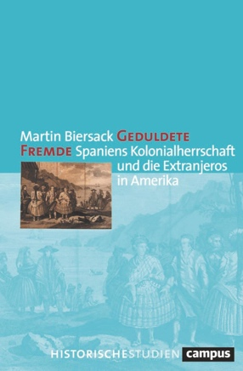
中文书名：《被宽容的陌生人：西班牙的殖民统治与美洲的外来人口》
英文书名：Tolerated Strangers: Spain's Colonial Rule and the Extranjeros in America
德语书名：Geduldete Fremde: Spaniens Kolonialherrschaft und die Extranjeros in Amerika
作 者：Martin Biersack
出 版 社：Campus Verlag
代理公司：ANA/Lauren
出版时间：2023年8月
代理地区：中国大陆、台湾
页 数：491页
审读资料：电子稿
类 型：大众社科

内容简介：

西班牙殖民统治的一个特点是明令禁止“外国人”前往美洲旅行或定居。然而，许多来自英国、葡萄牙、意大利或法国的移民却生活在西班牙-美洲殖民地。这些“外来移民”经常被下令驱逐，但实际上很少付诸实施，这些移民也成为研究重点。马丁·比尔萨克（Martin Biersack）探讨了“西班牙人”与“外国人”、规范与其实施情况、宽容与驱逐之间相互矛盾且经常处于紧张状态的关系，解释了非西班牙裔移民虽被排除在社会之外，但又如何以及为何成功融入前现代殖民社会的。

作者简介：

马丁·比尔萨克（Martin Biersack），哲学博士，在慕尼黑大学（Ludwig-Maximilians-Universität München）从事教学和研究工作。2021年和2022年，他作为费奥多·吕南奖学金获得者在马德里自治大学工作。

感谢您的阅读！
请将反馈信息发至：版权负责人
Email：Rights@nurnberg.com.cn
安德鲁·纳伯格联合国际有限公司北京代表处
北京市海淀区中关村大街甲59号中国人民大学文化大厦1705室, 邮编：100872
电话：010-82504106, 传真：010-82504200
公司网址：http://www.nurnberg.com.cn
书目下载：http://www.nurnberg.com.cn/booklist_zh/list.aspx
书讯浏览：http://www.nurnberg.com.cn/book/book.aspx
视频推荐：http://www.nurnberg.com.cn/video/video.aspx
豆瓣小站：http://site.douban.com/110577/
新浪微博：安德鲁纳伯格公司的微博_微博 (weibo.com)
微信订阅号：ANABJ2002

