新 书 推 荐

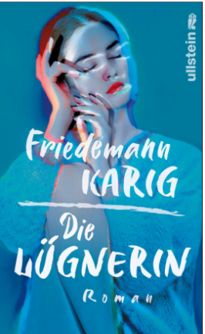
中文书名：《说谎者》
英文书名：The Liar
德语书名：Die Lügnerin
作 者：Friedemann Karig
出 版 社：Ullstein
代理公司：ANA/Lauren
出版时间：2023年8月
代理地区：中国大陆、台湾
页 数：224页
审读资料：电子稿
类 型：大众文学

内容简介：

一家僻静的私人诊所里，一个女人自述了一件不可思议的事：她有说谎的天赋，她的每一个谎言最终都会变成现实。一次次的治疗和忏悔过程中，治疗师越来越怀疑这个女人的人生故事。她的人生是一个由一连串精心设计的欺骗、不可思议的巧合和非凡的运气所构成的壮观故事。

这位病人名叫克拉拉·康拉德（Clara Konrad），被迫说谎的问题伴随她一生。出于这个缘由，她在一家诡异的呼叫中心找到了一份占星师的工作，虽然她鄙视这份工作，但却非常擅长。一天，一位忠实的求助热线客户找到她：克拉拉设计的星座运势全部实现了，一个细节也不落下，她只想与克拉拉分享她的好运气。然而，灾难性的后果悄然而至。

克拉拉讲述促使她来到诊所的经历，像一个天才说书人，让治疗师自己也情不自禁地被迷住。结果，诊所开始怪事连连，治疗师终于认识到克拉拉的神奇力量和计谋有多厉害——治疗师自己早已成为克拉拉计划中的一部分。

本书为畅销书作家弗里德曼·卡里格（Friedemann Karig）的新作品，非常时髦，诗意的独创性和敏锐的观察力让读者为其着迷，本书揭晓了谎言是我们认识世界的基本方式，以及为什么相信比怀疑要容易得多。

作者简介：
弗里德曼·卡里格（Friedemann Karig）学习过媒体科学，政治，社会学和经济学。他为《南德意志报》，《南德意志报杂志》，《德国时代周报》和《滚石》撰稿。他著有小说《丛林》（Jungle），2017 年出版的《我们如何爱：一夫一妻制的终结》（How We Love：From the End of Monogamy）深受好评。卡里格在慕尼黑和柏林生活。

媒体评价：

“弗里德曼·卡里格（Friedemann Karig）这本关于机缘、占卜、命运和各种江湖骗子的有趣小说，不一定非得是预言家才能解出其中的“星象排列”。”
——丹尼斯·薛克（Denis Scheck）

“所有人都会撒谎，但所有人也都希望被人欺骗。这部小说告诉大家，诚实并不等于真相。”
——海伦.黑格曼（Helene Hegemann）

感谢您的阅读！
请将反馈信息发至：版权负责人
Email：Rights@nurnberg.com.cn
安德鲁·纳伯格联合国际有限公司北京代表处
北京市海淀区中关村大街甲59号中国人民大学文化大厦1705室, 邮编：100872
电话：010-82504106, 传真：010-82504200
公司网址：http://www.nurnberg.com.cn
书目下载：http://www.nurnberg.com.cn/booklist_zh/list.aspx
书讯浏览：http://www.nurnberg.com.cn/book/book.aspx
视频推荐：http://www.nurnberg.com.cn/video/video.aspx
豆瓣小站：http://site.douban.com/110577/
新浪微博：安德鲁纳伯格公司的微博_微博 (weibo.com)
微信订阅号：ANABJ2002

