新 书 推 荐

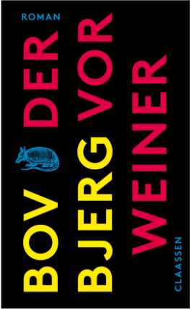
中文书名：《哭泣者》
英文书名：The Weeper
德语书名：Der Vorweiner
作 者：Bov Bjerg
出 版 社：Ullstein
代理公司：ANA/Lauren
出版时间：2023年8月
代理地区：中国大陆、台湾
页 数：240页
审读资料：电子稿
类 型：大众文学

内容简介：

残败的欧洲，世纪的末尾。内战和自然灾害摧毁了整个世界。海平面不断上升，整个大陆如搁浅的船一样，架在一层厚厚的混凝土上被高高抬起。来自丹麦、加纳或者荷兰的难民聚集在新天鹅堡和新吕贝克的难民营中。扬（Jan）就是其中之一。他以致哀者的身份为A.安娜（A. as in Anna）效力。

眼泪会带来声望。一个人的葬礼只有请到能干的“落泪首席”才在最后能收获真正令人信服的恸哭，因为没人再能真正地哀悼了。A.安娜的女儿B.贝尔塔（B. as in Berta）也做不到。B.贝尔塔是我们故事的叙述者，也是我们故事的“无睑之眼”（The lidless eye）。她的讲述充满喜剧色彩，却又不失轻松。

博夫·比约格（Bov Bjerg）的新作是一部大胆的尝试：如小步舞曲的巴洛克风格，如现场直播的现身说法，如预言家一样眼光长远。他对语言及其可能性有着敏锐的洞察力。《哭泣者》是一部关于荒诞世界的叙事艺术作品，值得收获大量奖项。

作者简介：

博夫·比约格（Bov Bjerg） 是一位作家和朗读表演者。他的第一部小说名为《最后期限》（Deadline），第二部小说《奥尔豪斯》（Auerhaus）被改编成电影，并在许多剧院上演。他的小说集《妈妈的现代化》（The Modernization of My Mother）已出版。《蜿蜒》（Serpentines）入围了2020年德国图书奖。

感谢您的阅读！
请将反馈信息发至：版权负责人
Email：Rights@nurnberg.com.cn
安德鲁·纳伯格联合国际有限公司北京代表处
北京市海淀区中关村大街甲59号中国人民大学文化大厦1705室, 邮编：100872
电话：010-82504106, 传真：010-82504200
公司网址：http://www.nurnberg.com.cn
书目下载：http://www.nurnberg.com.cn/booklist_zh/list.aspx
书讯浏览：http://www.nurnberg.com.cn/book/book.aspx
视频推荐：http://www.nurnberg.com.cn/video/video.aspx
豆瓣小站：http://site.douban.com/110577/
新浪微博：安德鲁纳伯格公司的微博_微博 (weibo.com)
微信订阅号：ANABJ2002

