新 书 推 荐

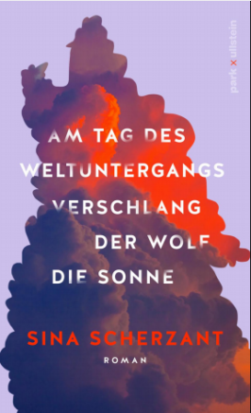
中文书名：《世界末日之狼噬日》
英文书名：On Doomsday, Wolf Devoured Sun
德语书名：Am Tag des Weltuntergangs verschlang der Wolf die Sonn
作 者：Sina Scherzant
出 版 社：Ullstein
代理公司：ANA/Lauren
出版时间：2023年8月
代理地区：中国大陆、台湾
页 数：336页
审读资料：电子稿
类 型：大众文学

内容简介：

卡塔（Katha）经营着一家“一人公司”（1-person business，指公司的出资全部属于单一股东的公司），且致力于讨好有人。从小，她就学会了适应、照顾和回避麻烦。虽然在修复父母的婚姻这件事上失败了，她仍继续热心地工作，即使母亲已经将卡塔和妹妹搬到了另一个城市。

学校里，卡塔与索菲（Sofie）和她的跟班们成了朋友，和她们一起在体育馆后面抽烟。在那里，她遇到了安吉莉卡（Angelica）。安吉丽卡既是女孩们的朋友，也是她们的代理家长，她倾听卡塔的心声，以前没人这样做过。安吉丽卡用她独特的方式，鼓励卡塔开始反思自己总是作为服务提供者为他人谋福利的角色，并学会开始照顾自己。但当安吉丽卡病倒后，卡塔的整个世界又变得岌岌可危。

很多人都能在这个青春女性的故事中找到自己的影子：那些因为害怕说错话而保持沉默的人，总是为他人带上面具，又逐渐在面具后丢失自我……

本书为畅销书作家西娜·舍尔赞特（Sina Scherzant）的第一部小说，既温柔又充满力量，既微妙有趣又充满千禧年早期的精彩细节——既是千禧一代的成长故事，也是关于如何做自己的永恒沉思。

作者简介：

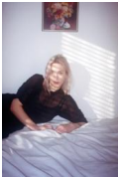
西娜·舍尔赞特（Sina Scherzant）是《环球时报》畅销书作家、播客、meme账号主理人和编剧。《世界末日之狼噬日》是她的文学处女作。

媒体评价：

“这是一个关于榜样力量的故事，情节引人入胜，情感细腻而让人心潮澎湃。必读！”
---卡佳•勒维纳（Katja Lewina）

感谢您的阅读！
请将反馈信息发至：版权负责人
Email：Rights@nurnberg.com.cn
安德鲁·纳伯格联合国际有限公司北京代表处
北京市海淀区中关村大街甲59号中国人民大学文化大厦1705室, 邮编：100872
电话：010-82504106, 传真：010-82504200
公司网址：http://www.nurnberg.com.cn
书目下载：http://www.nurnberg.com.cn/booklist_zh/list.aspx
书讯浏览：http://www.nurnberg.com.cn/book/book.aspx
视频推荐：http://www.nurnberg.com.cn/video/video.aspx
豆瓣小站：http://site.douban.com/110577/
新浪微博：安德鲁纳伯格公司的微博_微博 (weibo.com)
微信订阅号：ANABJ2002

