新 书 推 荐

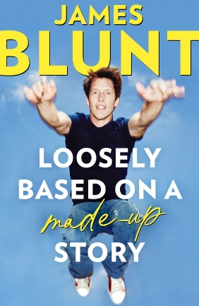
中文书名：《我编造的“真实”：一部“非回忆录”》
英文书名：Loosely Based On A Made-Up Story: A Non-Memoir
作 者：James Blunt
出 版 社：Constable
代理公司：PFD/ANA/Zoey
出版时间：2023年10月
代理地区：中国大陆、台湾
页 数：304页
审读资料：电子稿
类 型：传记回忆录

内容简介：

“本书灵感来源于真实事件，但并非传记。

这个‘真实’是我单方面解读的‘真实’，并非一定是客观‘真实’，这是大实话。这些事实确实偏颇，但不至令人痛苦，另外，我可能有所隐瞒。

基本上，这些瞎话都是我编出来的……”

虽然詹姆斯·布朗特（James Blunt）在音乐方面的“罪行”完全被“记录在案”，但有些故事还不为人知。詹姆斯·布朗特在这本算不上回忆录的回忆录中披露了前所未闻的、令人啼笑皆非的趣闻轶事，以飨各位读者，詹姆斯的父母都可能闻之一惊。

本书记录了他可疑的诺福克（Norfolk）出身、古怪的家庭、寄宿学校的滑稽行为、判断失误去服了兵役、身为音乐明星的崛起之路以及巡回演出等等逸事，詹姆斯深入探讨了迄今为止有趣的生活，常常让人目瞪口呆。母亲为了维护孩子的名誉给未来首相写了一封愤慨的邮件，这种情况该怎么办？为什么要避免“人群冲浪”（Crowd-surfing，指被乐迷在空中传递）？

这本书中的故事被严重夸大了吗？也许有。但要问值得一读吗？回答一定是“绝对值得”。

作者简介：
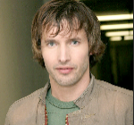
詹姆斯·布朗特（James Blunt）是英国创作型歌手、唱片制作人和前英国陆军军官。他在2004年发行了首张专辑Back to Bedlam，其中的热门单曲“You’re Beautiful”在全球售出超过1100万张，是2000年代英国最畅销的专辑，也是英国排行榜历史上最畅销的专辑之一。布朗特获得过两次全英音乐奖和五次格莱美奖提名。

感谢您的阅读！
请将反馈信息发至：版权负责人
Email：Rights@nurnberg.com.cn
安德鲁·纳伯格联合国际有限公司北京代表处
北京市海淀区中关村大街甲59号中国人民大学文化大厦1705室, 邮编：100872
电话：010-82504106, 传真：010-82504200
公司网址：http://www.nurnberg.com.cn
书目下载：http://www.nurnberg.com.cn/booklist_zh/list.aspx
书讯浏览：http://www.nurnberg.com.cn/book/book.aspx
视频推荐：http://www.nurnberg.com.cn/video/video.aspx
豆瓣小站：http://site.douban.com/110577/
新浪微博：安德鲁纳伯格公司的微博_微博 (weibo.com)
微信订阅号：ANABJ2002

