**新 书 推 荐**

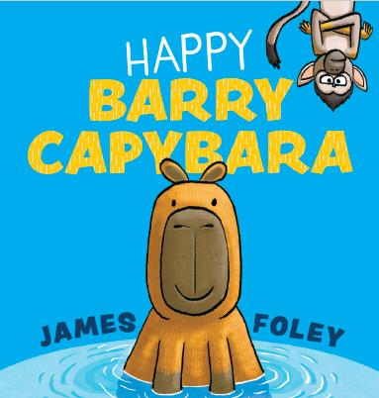**中文书名：《快乐的卡皮巴拉巴里》**

**英文书名：Happy Barry Capybara**

**作 者：James Foley**

**出 版 社：Scholastic Australia**

**代理公司：ANA**

**页 数：32页**

**出版时间：2024年11月**

**代理地区：中国大陆、台湾**

**审读资料：电子稿**

**类 型：儿童故事绘本**

**内容简介：**

**没有什么能让快乐的卡皮巴拉巴里烦恼。**

**在大草原上，天气寒冷的时候，它也很冷。**

**和他的朋友黄头狞猫一起玩耍。**

**不，没有什么能打扰快乐的卡皮巴拉巴里。**

快乐巴里（Happy Barry）是大草原上最冷酷的动物 因此，淘气的猴子哈里（Harry）决定要找巴里的麻烦。但是，从来没有什么能让快乐的卡皮巴拉巴里感到烦恼！

**本书卖点：**

·获奖作家/插画家詹姆斯·弗利（James Foley）的全新作品

·这是一本关于互联网上最受欢迎的动物--纸袋熊的书！

·巴里很淡定，拒绝让事情影响到他。他能教会淘气的猴子哈里如何让坏事过去吗？

·有趣的押韵文字，非常适合朗读。

**作者简介：**

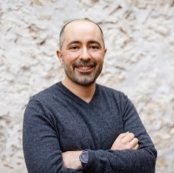**詹姆斯·弗利（James Foley）**为孩子们创作绘本，儿童文学和漫画。詹姆斯是S.Tinker Inc图像小说系列的作者兼插画家，也是Tim Harris的Toffle Towers系列的插图画家。詹姆斯较早的著作《我的死兔子》(My Dead Bunny)，《狮子》(In The Lion)，《最后的维京人》(The Last Viking)和《最后的维京人归来》(The Last Viking Returns)都获得了奖项，包括儿童选择奖，澳大利亚儿童图书委员会年度图书奖的入围名单，以及国际青年图书馆白乌鸦短名单。詹姆斯是“家中的书”（Books In Homes）和“澳大利亚读书室”（Room To Read Australia）的大使。[James Foley – Children's writer & illustrator](https://jamesfoley.com.au/)

**作者曾获奖：**

**Secret Agent Mole book 2: The Boar Identity**

**– Aussie Bookstagang Best Kids’ Graphic Novels of 2023**

**Secret Agent Mole book 1: Goldfish-Finger**

**– Shortlist, 2023 Taco Awards, Junior Book award**

**– Longlist, 2023 Taco Awards, Reluctant Reader award**

**Stellarphant**

**– Winner, 2022 Children’s Book Council of Australia Sun Project: Shadowers’ Choice Awards, Picture Book of the Year category**

**– Honour Book, 2022 Children’s Book Council of Australia Awards, Picture Book of the Year category**

**– Shortlist, WA Young Readers’ Book Awards, Picture Book category**

**– International Youth Library’s White Ravens List 2022**

**– 2022 Better Reading Top 50 Kids’ Books**

**– Shortlist, 2021 Aurealis Awards, Best Children’s Fiction category**

**– Shortlist, 2022 Society of Children’s Book Writers and Illustrators Members’ Choice Award (the ‘Crystal Kite’; Australia/NZ region)**

**– Shortlist, 2021 WA Premier’s Book Awards, The Premier’s Prize for Writing for Children**

**– Shortlist, Speech Pathology Australia’s Book of the Year Awards 2022**

**Chickensaurus**

**– Shortlist, 2021 Comic Arts Awards of Australia (the Ledgers)**

**– Longlist, 2020 Notable Australian Graphic Novels (Australian Library and Information Association, ALIA)**

**Toffle Towers, Book 1**

**– Shortlist, 2021 Kids’ Own Australian Literature Awards (KOALAs): Fiction for Older Readers category**

**– Shortlist, 2021 Young Australian Best Book Awards (YABBAs): Fiction for Older Readers category**

**– Shortlist, 2021 Kids’ Reading Oz Choice Awards (KROCs): Fiction for Older Readers category**

**Dungzilla**

**– Finalist, 2017 Aurealis Awards (Graphic Novel/Illustrated Work category)**

**– Shortlist, 2018 West Australian Young Readers’ Book Awards (Younger Readers category)**

**Brobot**

**– Shortlist, 2017 West Australian Young Readers’ Book Awards (Younger Readers category)**

**– Finalist, 2016 Aurealis Awards (Graphic Novel/Illustrated Work category)**

**My Dead Bunny**

**– Shortlist, 2016 Children’s Book Council of Australia Awards, Picture Book of the Year category**

**– Honour Award, 2017 Kids’ Own Australian Literature Awards (KOALAs)**

**– Shortlist, 2017 Young Australian Best Book Awards (YABBAs): Fiction for Older Readers category**

**– Shortlist, 2017 Kids’ Reading Oz Choice Awards (KROCs): Fiction for Older Readers category**

**The Last Viking Returns**

**– Winner, 2015 West Australian Young Readers’ Hoffman Award (highest-ranked book by a WA creator)**

**– Finalist, 2014 Aurealis Awards**

**In The Lion**

**– 2013 International Youth Library’s White Raven list**

**– Notable Book, 2013 Children’s Book Council of Australia Awards, Picture Book of the Year category**

**– Shortlist, 2014 West Australian Young Readers’ Book Awards (Picture Book category)**

**The Last Viking**

**– Winner, 2012 Society of Children’s Book Writers and Illustrators Members’ Choice Award (the ‘Crystal Kite’; Australia/NZ region)**

**– Winner, 2012 West Australian Young Readers’ Hoffman Award (highest-ranked book by a WA creator)**

**– Winner, 2012 Children’s Book Council of Australia Junior Judges Awards**

**– Shortlist, 2012 Children’s Book Council of Australia Awards, Early Childhood Book of the Year**

**– Notable Book, 2012 Children’s Book Council of Australia Awards, Picture Book of the Year**

**– Shortlist, 2012 Adelaide Festival Awards for Literature**

**– Finalist, 2011 Aurealis Awards**

**2010, 2007: ‘The Rigger’ Award for Outstanding Contribution to WA Cartooning (Australian Cartoonists’ Association).**

**2009: Shortlisted in the CYA Conference Competition, picture book category.**

**内页插图：**

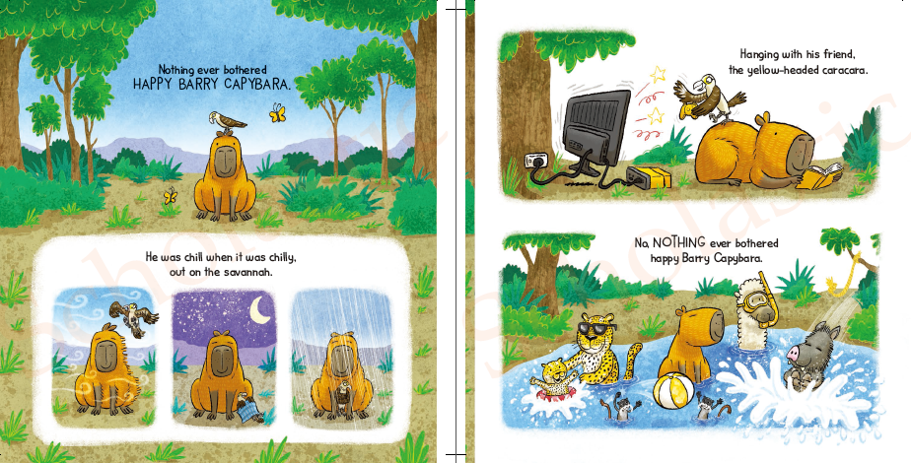

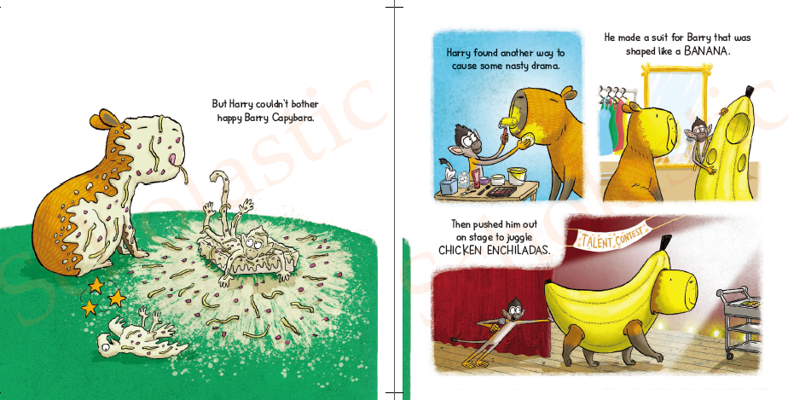

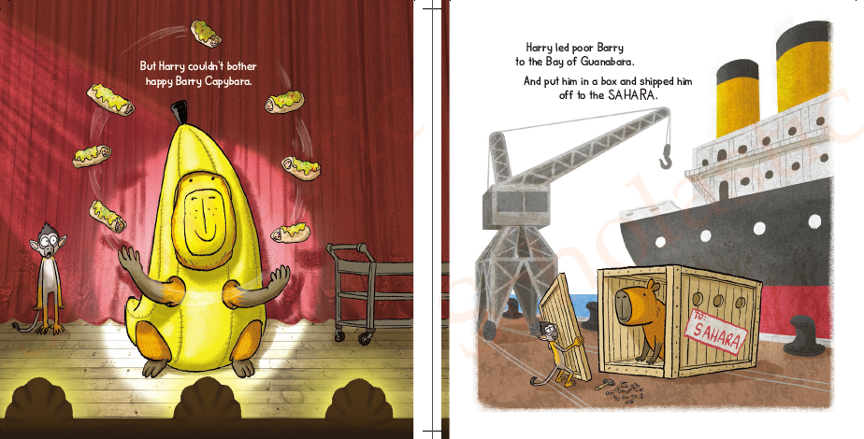

**感谢您的阅读！**

**请将反馈信息发至：版权负责人**

**Email**：[Rights@nurnberg.com.cn](mailto:Rights@nurnberg.com.cn)

安德鲁·纳伯格联合国际有限公司北京代表处

北京市海淀区中关村大街甲59号中国人民大学文化大厦1705室, 邮编：100872

电话：010-82504106, 传真：010-82504200

公司网址：[http://www.nurnberg.com.cn](http://www.nurnberg.com.cn/)

书目下载：<http://www.nurnberg.com.cn/booklist_zh/list.aspx>

书讯浏览：<http://www.nurnberg.com.cn/book/book.aspx>

视频推荐：<http://www.nurnberg.com.cn/video/video.aspx>

豆瓣小站：<http://site.douban.com/110577/>

新浪微博：[安德鲁纳伯格公司的微博_微博 (weibo.com)](https://weibo.com/1877653117/profile?topnav=1&wvr=6)

微信订阅号：ANABJ2002

