新 书 推 荐

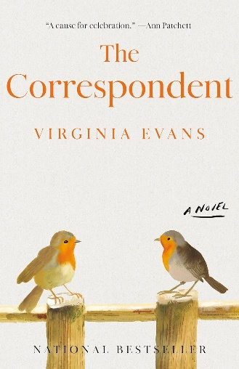
中文书名：《信使》
英文书名：THE CORRESPONDENT
作 者：Virginia Evans
出 版 社：Crown
代理公司：ANA/Jessica
页 数：304页
出版时间：2025年6月
代理地区：中国大陆、台湾
审读资料：电子稿
类 型：文学小说
版权已授：阿拉伯、克罗地亚、捷克、法国、德国、意大利、韩国、拉脱维亚、立陶宛、巴西、葡萄牙、乌克兰、西班牙、北美、土耳其
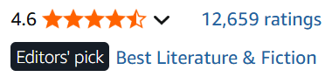

亚马逊畅销书榜排名：
#2 in Mothers & Children Fiction
#2 in Women's Domestic Life Fiction
#5 in Contemporary Women Fiction

原书出版社Crown：THE CORRESPONDENT by Virginia Evans has now moved to New York Times bestselling status, hitting the list at #12! We went out with 6,000 copies initially this past spring, and we’ve now entered the six-figure+ range in sales (across formats). It is a gem on the Crown Fiction list, and we’re thrilled that others think so as well!

内容简介：

这是一部书信体小说，结合了《一个叫欧维的男人决定去死》（A Man Called Ove）与《查令十字街84号》（84 Charing Cross Road）的风格，讲述经历生命寒冬的一个女人，试图用自己所知道的唯一方式——书信——来修补和感知这个世界。

本书苦乐参半，怀旧又令人耳目一新，充满魅力，是假期阅读的佳作！

在写给家人、朋友、邻居、前同事（甚至还有一些著名作家——她是个文学爱好者！）的信中，读者能了解退休律师西比尔·范·安特卫普（Sybil Van Antwerp）的生活，故事开始于70岁时。 西比尔固执、脾气暴躁、过于自以为是，但不知为何，又无比吸引人。她对自己和周围人生活的思考、反省和看法颇为打动人心，往来的书信记录了几年来在她的世界里来来去去的一群了不起的人物。这些书信有的普通而简单，有的则深刻又深沉。婚姻、母爱、亲情、友情，抑或失落、悲伤、衰老，各种主题都有涉及。这个感人至深的故事，能让大家在放下书信后久久不能忘怀

作者简介：

弗吉尼亚·埃文斯（Virginia Evans）拥有爱尔兰都柏林三一学院创意写作硕士学位。她发表过一些散文和短篇小说，在《爱尔兰时报》上发表过一篇关于她和家人在爱尔兰生活的散文。她与丈夫、孩子和爱犬布里吉德（Brigid）居住在北卡罗来纳州温斯顿·塞勒姆。

媒体评论：

“情节巧妙，故事精细，展示了个体生命的成长。维吉尼亚·埃文斯描绘了一个女人是如何在看似不可能改变的时刻发生改变的。这种变化，就像这本小说一样，是值得庆祝的。”
—— 安·帕切特（Ann Patchett）

“才华横溢的弗吉尼亚·埃文斯(Virginia Evans)写了一部关于联系和大胆的小说。故事主角西比尔·范·安特卫普(Sybil Van Antwerp)是一位到了一定年龄的单身女士，她通过写信找到了自己生活的意义，以及她所爱(或不爱)的人。那些接受和回复西比尔信件的角色们，都充满活力和丰富。西比尔挺过了创伤、悲伤和失去的爱。她保守秘密，编辑痛苦。这些信写得如此精美，西比尔的生活本身就成了一件艺术品。”
——阿德里安娜·特里贾尼（Adriana Trigiani），畅销书《未完成的美好》的作者

“The Correspondent is at turns amusing and, poignant and ultimately, a pleasure to read. This moving novel unfurls its truths one letter at a time, filling in a complex and memorable picture of one woman’s life. Like a handwritten letter at its best, The Correspondent is meant to be savored.”
----Charmaine Wilkerson, New York Times bestselling author of Black Cake

“This novel is a complete and utter joy.”
----Ann Napolitano

“Evans’s enchanting epistolary novel revolves around prickly septuagenarian Sybil Van Antwerp . . . [with] a dash of mystery that keeps the pages flying.”
----The Washington Post

“The charming debut from Evans takes the form of letters and emails exchanged by a divorced and retired woman with her friends, family, foes, and literary idols. . . . the detailed connections between each character are brilliantly mapped through the correspondence. It adds up to an appealing family drama.”
----Publishers Weekly

“I finished this wonderful, wonderful book in tears, and had to take a moment—several moments—to pull myself together. . . . Equal parts sorrow and quiet joy, the stuff of life, it will make you laugh, it will make you cry, it will make you reflect, as all the best novels do.”
----Fran Littlewood, New York Times bestselling author of Amazing Grace Adams

“I can’t praise it enough. Sybil is such a wonderful character, and the supporting cast so vivid and real. For a book about grief and regret it was also properly funny. It’s an absolute triumph.”
----Clare Chambers, bestselling author of Small Pleasures and Shy Creatures

“Thank you, Virginia Evans, for a life beautifully told in letters, for creating a character whose mind struggles with her heart in a most intriguing, sympathetic, witty, and binge-worthy way.”
----Elinor Lipman, author of Ms. Demeanor

“The Correspondent is the rarest of debuts with not a misplaced word or beat missed. Moving, funny and exquisite, it is a masterpiece in human frailty.”
----Anne Griffin, #1 Irish bestselling author of When All Is Said

“What a lovely novel, I fell in love with the eloquent, stubborn Sybil, such a wonderful character.”
----Margot Livesey, New York Times bestselling author of The Flight of Gemma Hardy and The Road from Belhaven

感谢您的阅读！
请将反馈信息发至：版权负责人
Email：Rights@nurnberg.com.cn
安德鲁·纳伯格联合国际有限公司北京代表处
北京市海淀区中关村大街甲59号中国人民大学文化大厦1705室, 邮编：100872
电话：010-82504106, 传真：010-82504200
公司网址：http://www.nurnberg.com.cn
书目下载：http://www.nurnberg.com.cn/booklist_zh/list.aspx
书讯浏览：http://www.nurnberg.com.cn/book/book.aspx
视频推荐：http://www.nurnberg.com.cn/video/video.aspx
豆瓣小站：http://site.douban.com/110577/
新浪微博：安德鲁纳伯格公司的微博_微博 (weibo.com)
微信订阅号：ANABJ2002


