系 列 推 荐
《我是》系列（5册）
I’M Series (5 books)
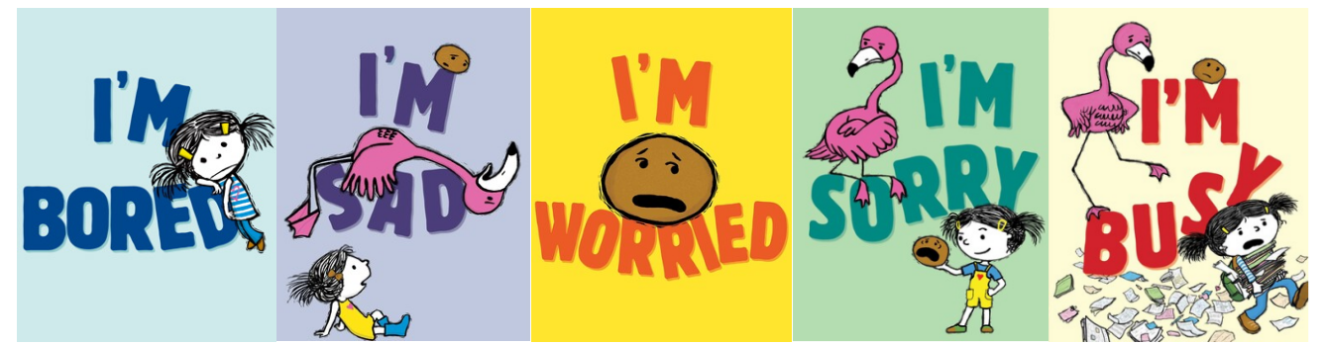
- 版权已授：Matar（以色列）、Daekyo（韩国）、Nasza Księgarnia（波兰）、Ye Ren（台湾）。插画版权归CB所有，文字版权归S&S所有。
- 开篇之作《我好无聊》荣膺《纽约时报书评》年度瞩目童书，其余几部均有国际奖项。
- 系列由《纽约时报》畅销书作家兼喜剧演员迈克尔·伊恩·布莱克与获奖插画家黛比·里德帕斯·奥希联袂创作。
- 五册书围绕五种核心情绪展开，传递了接纳情绪、珍视陪伴的深刻道理。
- 系列获得了包括《出版人周刊》（星级评论）、《科克斯书评》、《学校图书馆杂志》、《纽约时报》、《环球邮报》等西方主流童书评论媒体的高度评价。

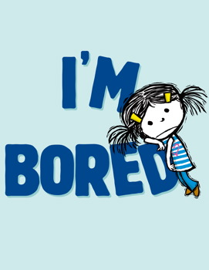
中文书名：《我好无聊》（第1册）
英文书名：I’m Bored
作 者：Michael Ian Black and Debbie Ridpath Ohi
出 版 社：Simon & Schuster
代理公司：Curtis Brown US/ANA
页 数：40页
出版时间：2012年9月
代理地区：中国大陆、台湾
审读资料：电子稿
类 型：故事绘本

Missouri Building Block Picture Book Award Nominee
New York Times Book Review Notable Books

内容简介：

There is NOTHING boring about being a kid, but one little girl is going to have to prove it in this anything-but-boring picture book from comedian Michael Ian Black.

Just when a little girl thinks she couldn’t possibly be more bored, she stumbles upon a potato who turns the tables on her by declaring that children are boring. But this girl isn’t going to let a vegetable tell her what’s what, so she sets out to show the unimpressed potato all the amazing things kids can do. Too bad the potato is anything but interested….

This tongue-in-cheek twist on a familiar topic is sure to entertain anyone who’s ever been bored—or had to hear about someone else being bored—and is filled with comedian Michael Ian Black’s trademark dry wit, accompanied by charismatic illustrations from newcomer Debbie Ridpath Ohi.

媒体评论：

* "Black (A Pig Parade Is a Terrible Idea) keeps this simple concept funny all the way through its final, LOL zinger. Debut illustrator Ohi’s minimalist, scraggly digital drawings are anything but boring, and speak volumes about irritation, desperation, and disdain."--Publishers Weekly, starred review

"Genuinely funny moments.... [The girl] demonstrates cartwheels, ninja kicks and imagination games—lion taming; dragons and swords; forcing the potato to walk a pirate-ship plank—all of which Ohi sketches in pale blue."– Kirkus Reviews

"Ohi’s captivating, digitally created illustrations are full of wit and charm.... Quirky and fun to read aloud, this book is a sure antidote for cases of ennui."
– School Library Journal

A Notable Children's Book Of 2012
– The New York Times Sunday Book Review

"[Michael Ian] Black, a comedian, has become a fine children's book storyteller.... Readers will not be bored."
– The New York Times Book Review

"Beautifully written by Michael Ian Black and gorgeously illustrated by Debbie Ridpath Ohi... It has the courage to go unfashionably old-school and suggest that our imagination, not our gadgets, is the only cure [for boredom].... Both the writing and the illustrations are fearless."
– The Globe & Mail

"Fans of Mo Willems’ Elephant and Piggie series will delight in the latest book by American comedian Michael Ian Black, illustrated by Toronto graphic artist Debbie Ridpath Ohi. Echoing Willems, Black’s story is constructed around the dialogue of an unlikely couple, in this case a small girl and a potato. The text is perfectly complemented by Ohi’s quirky minimalist drawings."
– Quill & Quire

"Sometimes a picture book gets it just right. And by 'it,' I mean clever concept, smart execution and all-around child-friendly vibe. It’s rare for one of those picture books to have been written by a so-called celebrity author—someone who made a name for him or herself in Hollywood and then decided to write children’s books—but Michael Ian Black has proven to be the exception to the rule."
– Julie Danielson, Kirkus Reviews blog

"Black...tells his story in sprightly fashion. The illustrator Debbie Ridpath Ohi convincingly draws a child full of life, a potato full of — well, potatotude, and computer drawings that look just like good old-fashioned linocuts. Her smart cartoony artwork matches Black’s perfect comic timing, making for a fun ride that should leave you amused, perhaps pensive, and no longer bored."
– The New York Times Sunday Book Review

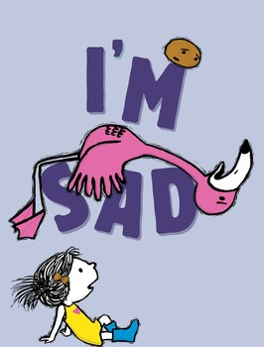
中文书名：《我很伤心》（第2册）
英文书名：I’m Sad
作 者：Michael Ian Black and Debbie Ridpath Ohi
出 版 社：Simon & Schuster
代理公司：Curtis Brown US/ANA
页 数：40页
出版时间：2018年6月
代理地区：中国大陆、台湾
审读资料：电子稿
类 型：故事绘本

Land of Enchantment RoadRunner Award Nominee (NM)

内容简介：

A girl, a potato, and a very sad flamingo star in this charming sequel to I’m Bored by New York Times bestselling author and comedian Michael Ian Black and celebrated illustrator Debbie Ridpath Ohi.

Everyone feels sad sometimes—even flamingos.

Sigh.

When Flamingo announces he’s feeling down, the little girl and Potato try to cheer him up, but nothing seems to work. Not even dirt! (Which usually works for Potato.)

Flamingo learns that he will not always feel this way. And his friends learn that sometimes being a friend means you don’t have to cheer someone up. You just have to stick by your pal no matter how they feel.

Even if they’re a potato.

媒体评论：

"Bibliotherapy done right." - Kirkus

"A lighthearted approach to a common tough topic." - School LIbrary Journal

[I]n I’m Sad, the funny and tender-hearted follow-up to 2012’s I’m Bored, a girl, a potato and a flamingo learn that sometimes, the only way to cope with negative feelings is by giving yourself the time and space to fully feel them.
– The Globe and Mail

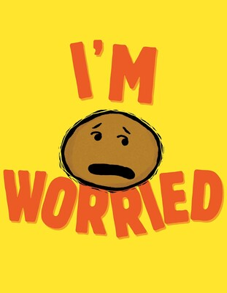
中文书名：《我很担心》（第3册）
英文书名：I’m Worried
作 者：Michael Ian Black and Debbie Ridpath Ohi
出 版 社：Simon & Schuster
代理公司：Curtis Brown US/ANA
页 数：40页
出版时间：2021年8月
代理地区：中国大陆、台湾
审读资料：电子稿
类 型：故事绘本

Kansas NEA Reading Circle List PrimaryTitle
ILA Children’s Choices Reading List
Picture This Recommendation List

内容简介：

A girl, a flamingo, and a worried potato star in the third book in New York Times bestselling author Michael Ian Black and celebrated illustrator Debbie Ridpath Ohi’s series about feelings—and why they’re good, even when they feel bad.

Potato is worried. About everything.

Because anything might happen.

When he tells his friends, he expects them to comfort him by saying that everything will be okay. Except they don’t. Because it might not be, and that’s okay too. Still, there’s one thing they can promise for sure: no matter what happens…they will always be by his side.

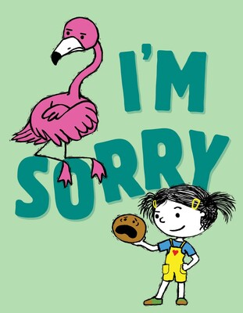
中文书名：《我很抱歉》（第4册）
英文书名：I’m Sorry
作 者：Michael Ian Black and Debbie Ridpath Ohi
出 版 社：Simon & Schuster
代理公司：Curtis Brown US/ANA
页 数：40页
出版时间：2021年9月
代理地区：中国大陆、台湾
审读资料：电子稿
类 型：故事绘本

内容简介：

In this fourth book in the series from New York Times bestselling author Michael Ian Black and celebrated illustrator Debbie Ridpath Ohi, a flamingo and a very sorry potato learn how to mend hurt feelings.

Flamingo is upset. Very upset.

Potato is sorry. Very sorry. In fact, he is the sorriest.

But he doesn’t know how to tell Flamingo. He would rather run away to the South Pole and live with penguins. He’d rather wear a disguise for the rest of time. But will that be enough to fix their friendship? Will they ever go back to being a girl, a potato, and a flamingo again?

中文书名：《我好忙》（第5册）
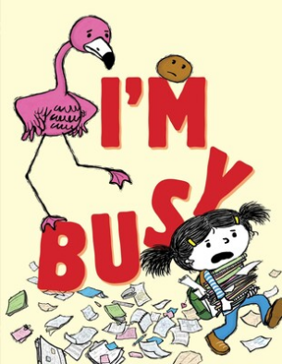
英文书名：I’m Busy
作 者：Michael Ian Black and Debbie Ridpath Ohi
出 版 社：Simon & Schuster
代理公司：Curtis Brown US/ANA
页 数：40页
出版时间：2026年2月
代理地区：中国大陆、台湾
审读资料：电子稿
类 型：故事绘本

内容简介：

In this fifth book in the series from New York Times bestselling author Michael Ian Black and celebrated illustrator Debbie Ridpath Ohi, a flamingo, a girl, and a potato tackle what it’s like to feel super-busy-all-the-time.

So much to do and so little time! How can a girl get everything done?

Especially when Potato and Flamingo are asking her to hula hoop or play superheroes, when she has more important things to do, like piano practice, Spanish lessons, solving mysteries, and getting into the right college. Okay, that might be too much…

Can friends can help her find some balance and understand that no matter how busy you get, you should always find time for your friends?

内页插图：

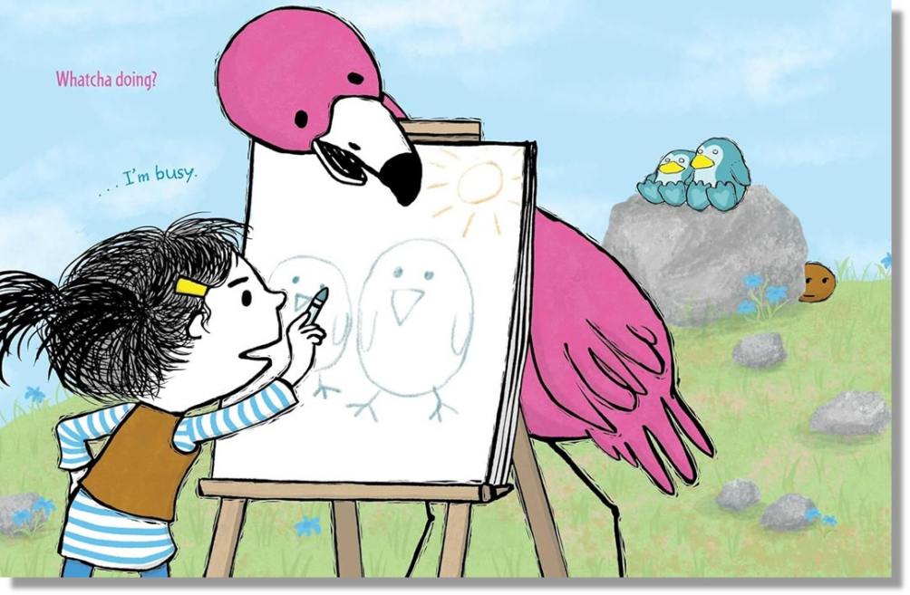
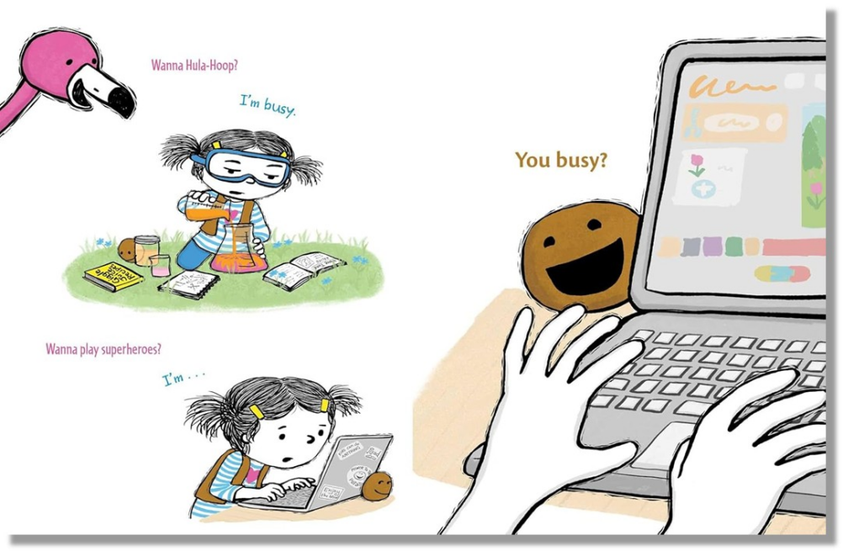

作者简介：


Debbie Ridpath Ohi’s writing or art has appeared in over twenty books for young people. She is the award-winning author and illustrator of Where Are My Books?, I Want to Read ALL the Books, and Sam & Eva with Simon & Schuster. Her illustrations appear in books by Judy Blume, Michael Ian Black, and Linda Sue Park, among others. Debbie lives with her husband in Toronto, Canada. For more info, see DebbieOhi.com.


Michael Ian Black is a writer, comedian, and actor who has appeared on Another Period, The Jim Gaffigan Show, and Wet Hot American Summer: First Day of Camp. He created and starred in many television series, has written screenplays, and regularly tours the country as a stand-up comedian. Michael is the bestselling author of the book My Custom Van, the memoir You’re Not Doing It Right, and the children’s books Chicken Cheeks, The Purple Kangaroo, A Pig Parade Is a Terrible Idea, I’m Bored, Naked!, Cock-a-Doodle-Doo-Bop!, and I’m Sorry. Michael lives in Connecticut with his wife and two children.

请将反馈信息发至：版权负责人
Email：Rights@nurnberg.com.cn
安德鲁·纳伯格联合国际有限公司北京代表处
北京市海淀区中关村大街甲59号中国人民大学文化大厦1705室, 邮编：100872
电话：010-82504106, 传真：010-82504200
公司网址：http://www.nurnberg.com.cn
书目下载：http://www.nurnberg.com.cn/booklist_zh/list.aspx
书讯浏览：http://www.nurnberg.com.cn/book/book.aspx
视频推荐：http://www.nurnberg.com.cn/video/video.aspx
豆瓣小站：http://site.douban.com/110577/
新浪微博：安德鲁纳伯格公司的微博_微博 (weibo.com)
微信订阅号：安德鲁纳伯格联合国际北京代表处

