新 书 推 荐
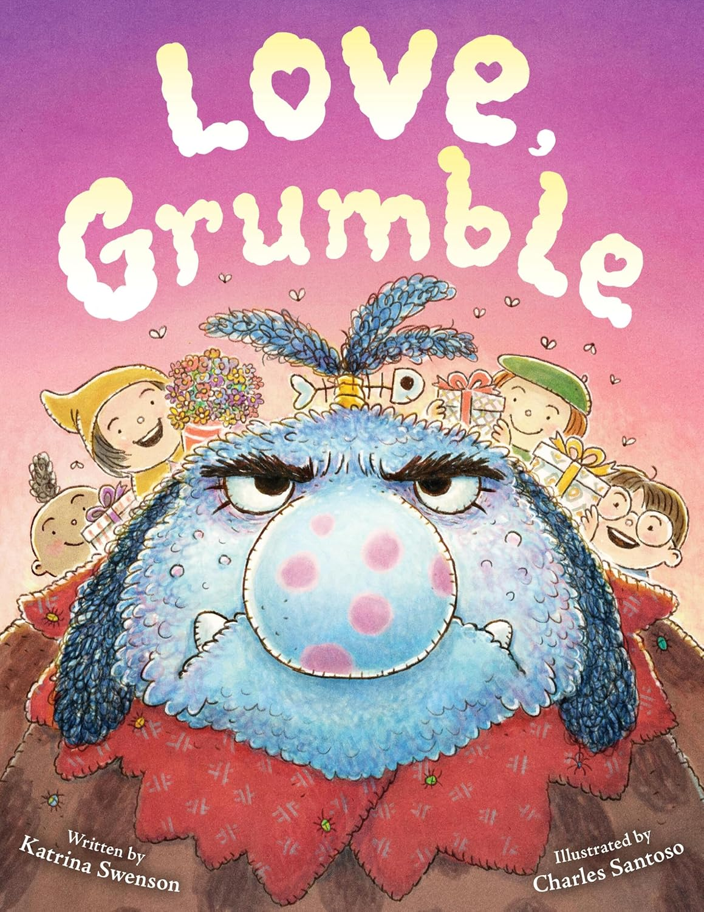
中文书名：《爱发牢骚的格鲁姆》
英文书名：LOVE GRUMBLE
作 者：Katrina Swenson and Charles Santoso
出 版 社：Little Brown
代理公司：Little Brown
页 数：40页
出版时间：2026年11月
代理地区：中国大陆、台湾
审读资料：电子稿
类 型：故事绘本

牢骚满满，爱意暖暖
爱不只有甜腻糖果，也可以是安静陪伴
暴躁巨魔的情人节奇遇，读懂爱的不同模样
教会孩子用对方喜欢的方式去表达
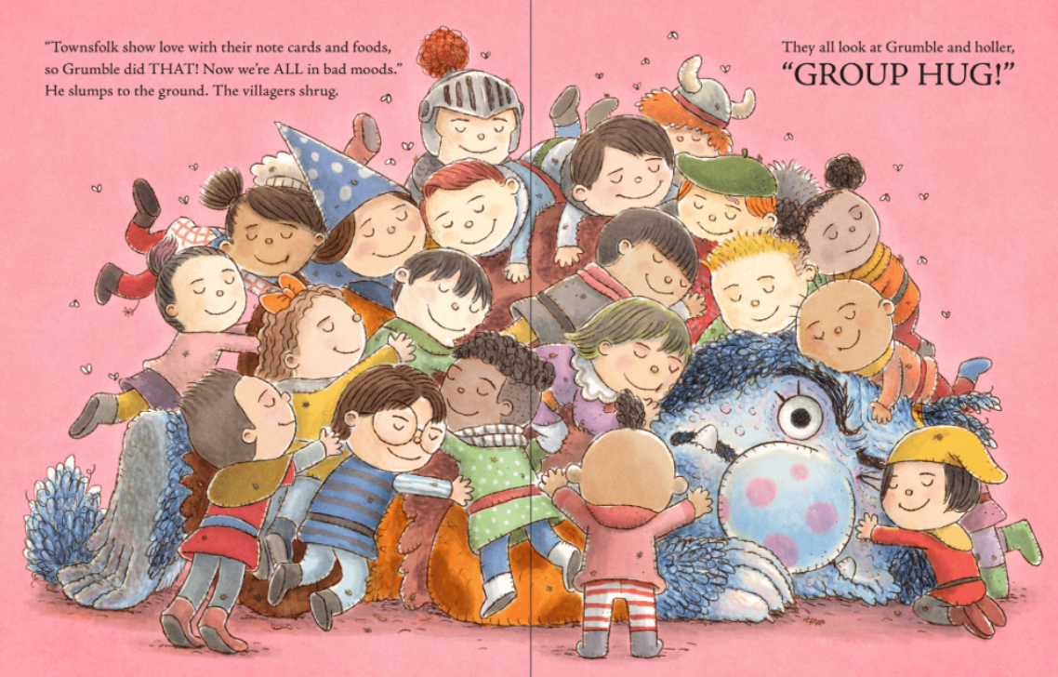

内容简介：

A surprisingly sweet and delightfully funny picture book about a grumpy troll who discovers that love can be shown in many ways.

Grumble the troll doesn’t understand why humans like to show affection with icky things like sweets and hearts. All he really wants is to be left alone. But when the village of Sweetbriar Ridge surprises him with a Valentine’s Day gift of solitude, Grumble is forced to consider that maybe love doesn’t totally stink and that the right kind can be okay—sometimes.

A charming message in rhyme makes this a guaranteed favorite for Valentine’s Day. Little listeners will love Grumble and his story will make it easy for adults to start conversations about showing love and the importance of considering what others prefer when sharing your love with them.

作者简介：

Katrina Swenson majored in English (writing emphasis) and Spanish at Loyola Marymount University and has a graduate degree in Counseling from Gonzaga University. She now lives in Olympia, Washington, with her husband, two kids, and a small clowder of cats. She spends her free time writing poetry for kids, and Love, Grumble is her picture book debut.

Charles Santoso loves drawing little things in his little journal and dreaming about funny, wondrous stories. He has illustrated many picture books, including I Will Read to You by Gideon Sterer; Dandy by Ame Dyckman; Odder: An Otter's Story by Katherine Applegate; Ida, Always by Caron Levis; and Dear Unicorn by Josh Funk. He divides his time between Singapore and Australia.

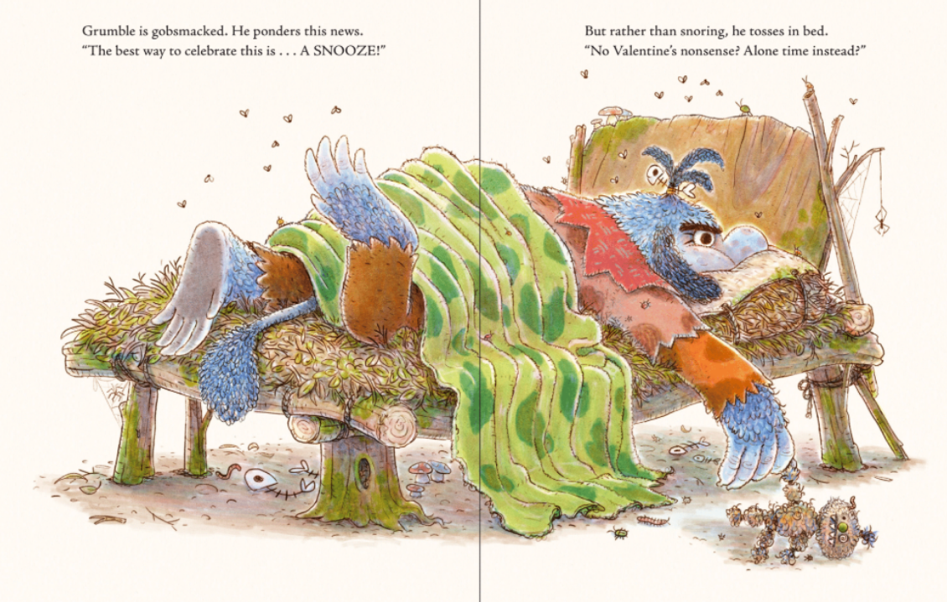

请将反馈信息发至：版权负责人
Email：Rights@nurnberg.com.cn
安德鲁·纳伯格联合国际有限公司北京代表处
北京市海淀区中关村大街甲59号中国人民大学文化大厦1705室, 邮编：100872
电话：010-82504106, 传真：010-82504200
公司网址：http://www.nurnberg.com.cn
书目下载：http://www.nurnberg.com.cn/booklist_zh/list.aspx
书讯浏览：http://www.nurnberg.com.cn/book/book.aspx
视频推荐：http://www.nurnberg.com.cn/video/video.aspx
豆瓣小站：http://site.douban.com/110577/
新浪微博：安德鲁纳伯格公司的微博_微博 (weibo.com)
微信订阅号：安德鲁纳伯格联合国际北京代表处

