新 书 推 荐
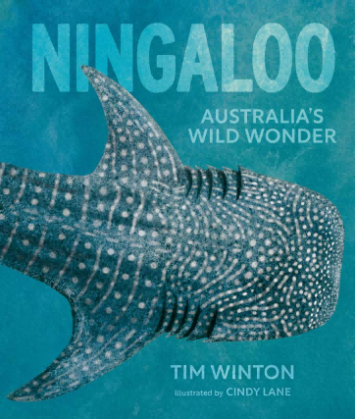
中文书名：《宁格鲁礁》
英文书名：NINGALOO
作 者：Tim Winton and Cindy Lane
出 版 社：Fremantle Press
代理公司：Fremantle Press
页 数：72页
出版时间：2025年10月
代理地区：中国大陆、台湾
审读资料：电子稿
类 型：科普读物

潜入宁格鲁，发现地球的野性之美：从珊瑚礁到红树林，从庞然大物到微观生命
下一代的海洋守护者，从读这本书开始：这本绝美绘本，让孩子在惊叹中读懂自然，
掌握保护宁格鲁的秘诀，培养敬畏之心与责任感！
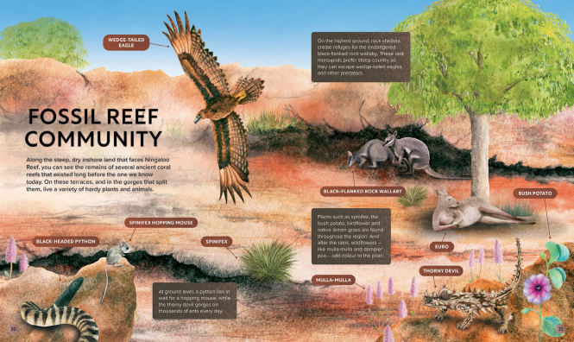

内容简介：

In the north of Western Australia, where the desert meets the sea, lies one of the last great wild regions on earth. The First Peoples of the region call it Nyinggulu. The rest of the world knows it as Ningaloo.

Join award-winning author and passionate conservationist Tim Winton and watercolourist Cindy Lane as they dive into this incredible part of the world. From enormous whale sharks to minuscule Cape Range millipedes, and from colourful coral reefs to muddy mangroves, the biodiversity and interconnectedness of each distinctive ecosystem will fill young readers with wonder and awe.

Most importantly, as the next generation of custodians of Ningaloo, they’ll discover how to support and protect the region in the years to come.

媒体评价：

“Lane’s beautifully realistic illustrations are rich with layered detail, drawing readers into the vibrant reef. The pages are filled with fascinating facts about sea creatures, diverse fauna and stories of the First Nations peoples and their long history with the reef.”
——Books+Publishing
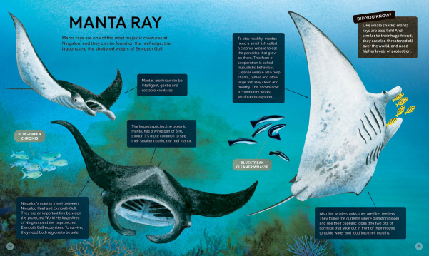
作者简介：


Tim Winton was born in Perth, Australia in 1960. A four-time winner of the Miles Franklin Award and shortlisted twice for the Booker Prize, Winton is a bestselling author whose work has been adapted for the stage and screen and is widely translated.


Cindy Lane is a Perth-based artist, illustrator and children’s book creator. Her first picture book, Great White Shark (written by Claire Saxby), won the Royal Zoological Society of NSW Whitely Award Best Children’s Book for 2022, and Cindy was listed on the CBCA Shortlist for New Illustrator in 2022.

请将反馈信息发至：版权负责人
Email：Rights@nurnberg.com.cn
安德鲁·纳伯格联合国际有限公司北京代表处
北京市海淀区中关村大街甲59号中国人民大学文化大厦1705室, 邮编：100872
电话：010-82504106, 传真：010-82504200
公司网址：http://www.nurnberg.com.cn
书目下载：http://www.nurnberg.com.cn/booklist_zh/list.aspx
书讯浏览：http://www.nurnberg.com.cn/book/book.aspx
视频推荐：http://www.nurnberg.com.cn/video/video.aspx
豆瓣小站：http://site.douban.com/110577/
新浪微博：安德鲁纳伯格公司的微博_微博 (weibo.com)
微信订阅号：安德鲁纳伯格联合国际北京代表处

