新 书 推 荐
《彩窗寻宝记》
THE TREASURE SEEKERS
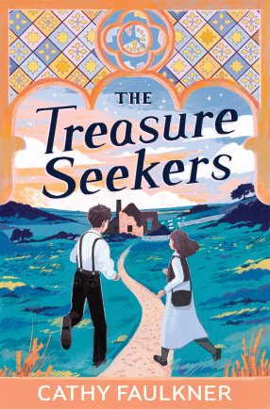
中文书名：《彩窗寻宝记》
英文书名：THE TREASURE SEEKERS
作 者：Cathy Faulkner
出 版 社：Firefly Press
代理公司：PFD
页 数：待定
出版时间：2026年2月5日
代理地区：中国大陆、台湾
审读资料：电子稿
类 型：儿童文学

“一战余韵下，追寻失落彩窗，守护家园与爱”
卡内基奖、布兰福德・博伊斯奖、UKLA 图书奖长名单、雷德布里奇图书奖等多项大奖入围作家
《战地掘光者》作者全新力作，书写友谊的力量与冒险的悸动

本书卖点：

·大奖作家背书，品质口碑双保障：作者前作《战地掘光者》（Digging for Victory）入围卡内基奖、布兰福德・博伊斯奖、英国文学奖，斩获雷德布里奇图书奖，文学实力备受认可。

·独特韵文体裁，文学质感突出：以诗意韵文书写历史冒险，文字优美、节奏流畅，兼具文学性与可读性，区别于普通叙事类儿童小说。

·温情历史内核，情感共鸣强烈：一战背景下的小镇往事，融合家园守护、亲情羁绊、友谊成长，基调温暖治愈，兼具历史厚重感与少年成长的纯粹。

·双线寻宝悬念，剧情张力十足：神秘教堂彩窗、祖父的秘密、母亲的怪病、战后创伤…… 悬念层层交织，寻宝过程扣人心弦，适合亲子共读与课堂阅读。

内容简介：

Stanley is convinced that the stained-glass window in the church that Martha’s late grandfather removed during the war is the protection the village needs to solve all its problems, including his mother’s sickness. But Martha refuses to help him search for the window panels, wanting to keep her beloved grandfather’s secrets safe.

When Stanley becomes ill as well, Martha realises she must act to help him. She begins her search for the panels, even as her father struggles with his own inner-turmoil in the aftermath of the war. As the people who are most important to them suffer, Martha and Stanley step up their search.

Can all the panels be found before it’s too late?

作者简介：

Cathy Faulkner has a BA in English Literature and an MA in Writing for Young People. She has taught in schools, colleges and universities in England and abroad, and currently teaches at the University of Bristol. Besides writing, she loves gardening, musical theatre and making stained glass windows.

请将反馈信息发至：版权负责人
Email：Rights@nurnberg.com.cn
安德鲁·纳伯格联合国际有限公司北京代表处
北京市海淀区中关村大街甲59号中国人民大学文化大厦1705室, 邮编：100872
电话：010-82504106, 传真：010-82504200
公司网址：http://www.nurnberg.com.cn
书目下载：http://www.nurnberg.com.cn/booklist_zh/list.aspx
书讯浏览：http://www.nurnberg.com.cn/book/book.aspx
视频推荐：http://www.nurnberg.com.cn/video/video.aspx
豆瓣小站：http://site.douban.com/110577/
新浪微博：安德鲁纳伯格公司的微博_微博 (weibo.com)
微信订阅号：安德鲁纳伯格联合国际北京代表处

