新 书 推 荐
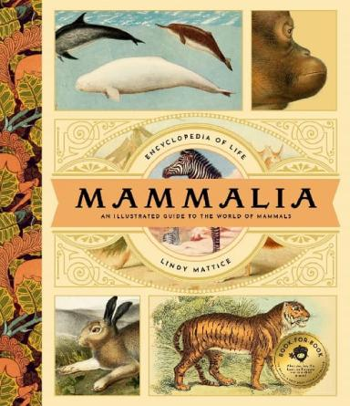
中文书名：《哺乳动物：世界哺乳动物图鉴》
英文书名：Mammalia: An Illustrated Guide to the World of Mammals
作 者：Lindy Mattice
出 版 社：Bushel & Peck Books
代理公司：Biagi
页 数：144页
出版时间：2024年6月
代理地区：中国大陆、台湾
审读资料：电子稿
类 型：科普读物
版权已授：法语/法国拉玛蒂尼埃少儿出版社（La Martiniere Jeunesse），意大利语/ 意大利迪亚戈斯蒂尼出版社（De Agostini）

【本书亮点】
【硬核科普】超过125种哺乳动物、数百幅复古版画、140页严谨的图谱与分类树
这不是一本普通图鉴，而是一座可触摸的哺乳动物博物馆
【当科学遇见艺术】世界顶级动物艺术家的手绘杰作，带你穿越时光，窥见哺乳王国的壮丽全貌
【生命教育】和孩子一起翻开这本书，进行关于生命归属感的温暖对话。这本书提醒我们：人类，也是这迷人哺乳家族的一员

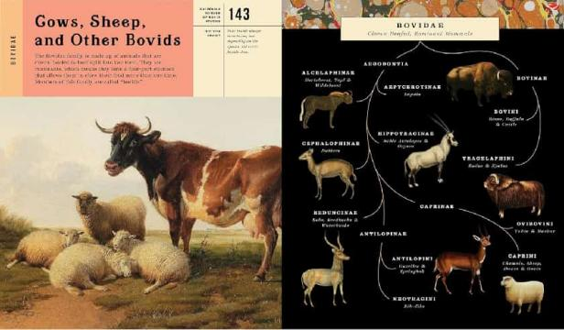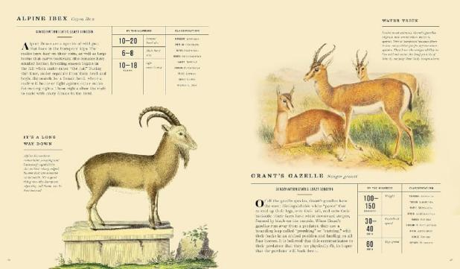

内容简介：

A breathtaking visual encyclopedia of the world's most fascinating mammals!

Featuring more than 125 amazing mammals and hundreds of vintage zoological illustrations, Mammalia is the gorgeous guide to the mammal class (a.k.a. home to you and me!). Enchanting artwork from some of the world's most accomplished zoological artists adorns over 140 pages of facts, charts, and taxonomic trees. Written by Lindy Mattice, author of How to Speak Animal, this visual tome is as stunning as it is informative and a must-have vintage treasure.

Animals include: American Bison, Bighorn Sheep, Astor Markhor, Black Wildebeest, Wild Water Buffalo, Alpine Ibex, Vampire Bat, Fruit Bat, Horseshoe Bat, Bismarck Masked Flying Fox, Moose, Reindeer, and more...
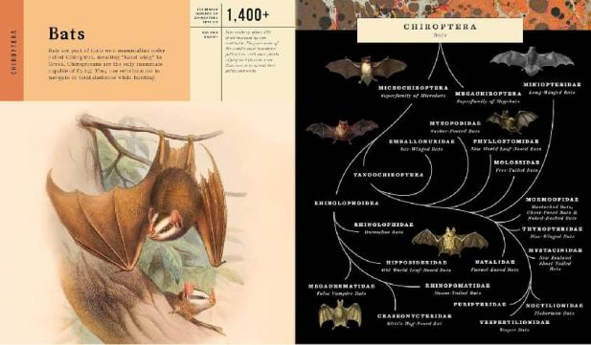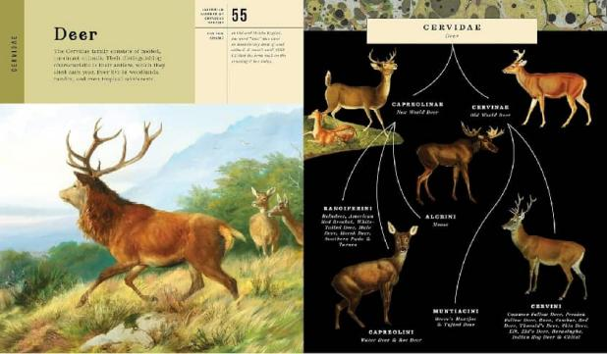

作者简介：

Lindy Mattice has always had a deep love for animals. When she was just seven years old, her family joined a wildlife rehabilitation organization where Lindy spent countless hours caring for young, orphaned animals who were eventually released back into the wild. She also worked with a local group as a pet detective, helping train dogs to search for lost pets. She was a member of the FFA (Future Farmers of America) organization, where she competed on the horse judging team and showed sheep. Lindy received her bachelor of science degree in agriculture science from Cal Poly. She currently resides in Bakersfield, California, with her husband and three children. She loves their family’s two dogs and cat and her weekly horseback riding lessons.

请将反馈信息发至：版权负责人
Email：Rights@nurnberg.com.cn
安德鲁·纳伯格联合国际有限公司北京代表处
北京市海淀区中关村大街甲59号中国人民大学文化大厦1705室, 邮编：100872
电话：010-82504106, 传真：010-82504200
公司网址：http://www.nurnberg.com.cn
书目下载：http://www.nurnberg.com.cn/booklist_zh/list.aspx
书讯浏览：http://www.nurnberg.com.cn/book/book.aspx
视频推荐：http://www.nurnberg.com.cn/video/video.aspx
豆瓣小站：http://site.douban.com/110577/
新浪微博：安德鲁纳伯格公司的微博_微博 (weibo.com)
微信订阅号：安德鲁纳伯格联合国际北京代表处

