新 书 推 荐
《同一轮明月下：中秋团圆故事》
BENEATH THE SAME ROUND MOON: A MOONCAKE FESTIVAL STORY

中文书名：《同一轮明月下：中秋团圆故事》
英文书名：BENEATH THE SAME ROUND MOON: A MOONCAKE FESTIVAL STORY
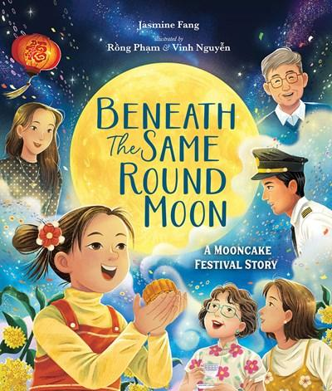
作 者：Jasmine Fang
插 画 师：Rồng Phạm and Vinh Nguyễn
出 版 社：Beaming Books
代理公司：Defiore
页 数：32页
出版时间：2026年9月
代理地区：中国大陆、台湾
审读资料：电子稿
类 型：4-7岁故事绘本

中秋民俗启蒙+亲情联结，聚焦异地团圆，融入实用民俗教程，适配4-7岁儿童，兼顾文化传播与情感共鸣
一个关于家人跨越距离彼此联结的中秋故事，非常适合亚洲读者、想要了解不同文化节日的读者，以及任何与远方家人一起庆祝节日的读者
一个关于家人即便相隔千里，依然能共同庆祝节日的中秋故事
详细呈现中秋传统习俗，书末附带月饼食谱及纸灯笼制作步骤

本书卖点：

·题材贴合需求：以中秋佳节为背景，聚焦异地家庭的团圆困境，精准戳中异地亲情共鸣点，同时适合亚洲读者及想要了解不同文化节日的读者。

·文化内涵丰富：详细呈现中秋传统习俗，书末附带月饼食谱及纸灯笼制作步骤，兼具故事性与实用性，助力儿童了解中秋文化、动手实践。

·情感共鸣强烈：讲述虚拟团圆的温暖故事，传递“距离隔不断亲情”的内核，引导儿童理解团圆的多元形式，感受家庭联结的力量。

·创作团队优质：作者兼具移民经历与全球视野，故事充满生活温度；插画师双人组合经验丰富，画风融合多种技法，贴合故事温情基调。

内容简介：

A Mid-Autumn Festival story about family connecting across distance, perfect for Asian readers, readers learning about different cultural holidays, and any reader who has celebrated a holiday with a family member long-distance.

A Mooncake Festival story about a family celebrating a holiday together, even when miles apart

Pearl is eager to welcome loved ones to her house for the traditional Mooncake Festival dinner. But her family is spread far and wide, and this year they won't be able to travel to reunite over the special dinner. Her big sister is away at college, her dad is working as an airline pilot, and her grandfather, Yéye, has passed away. Will it still be a special day with only Pearl, her mother, and her grandma?

When NǎiNai arrives with baskets of ingredients, the three generations work diligently to cook dinner, bake mooncakes, and make lanterns, with each element reminding Pearl of the people she misses. On the night of the Mooncake Festival, they need to be creative in how they celebrate as a family, showing Pearl that no matter where they are, her family is still connected beneath the same round moon.

A relatable story of celebrating virtually for holidays when families are separated by distance, and a reminder that our holiday traditions connect us even when we're not together in the same place. This Mid-Autumn Festival story includes lovely details about the traditions around this holiday, including backmatter with a mooncake recipe and instructions for making a paper lantern.

作者简介：

Jasmine Fang is a Taiwanese-American author whose books celebrate the beauty and messiness of everyday life. Her stories often draw from her 1.5-generation immigrant experience, her love of the outdoors and tennis, and her belief in the strength of the human spirit. Fang has worked in international affairs, higher education, and leadership development, bringing a global perspective to her storytelling. She holds a BA from UC Irvine and an MBA from Georgetown University. She lives in the San Francisco Bay Area with her husband and children.

插画师简介：

Rồng Phạm and Vinh Nguyễn are an illustrator duo from Saigon, Vietnam. With years of experience in publishing and advertising, they focus on children's picture books and cover art. Their work blends digital and mixed-media techniques, often inspired by nature, family, and the connections that shape everyday life.

请将反馈信息发至：版权负责人
Email：Rights@nurnberg.com.cn
安德鲁·纳伯格联合国际有限公司北京代表处
北京市海淀区中关村大街甲59号中国人民大学文化大厦1705室, 邮编：100872
电话：010-82504106, 传真：010-82504200
公司网址：http://www.nurnberg.com.cn
书目下载：http://www.nurnberg.com.cn/booklist_zh/list.aspx
书讯浏览：http://www.nurnberg.com.cn/book/book.aspx
视频推荐：http://www.nurnberg.com.cn/video/video.aspx
豆瓣小站：http://site.douban.com/110577/
新浪微博：安德鲁纳伯格公司的微博_微博 (weibo.com)
微信订阅号：安德鲁纳伯格联合国际北京代表处

