系 列 推 荐
《一直永远在一起》五册系列
ALWAYS, TOGETHER, FOREVER SERIES
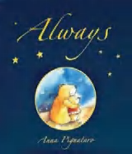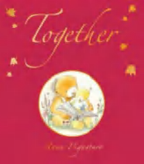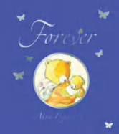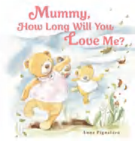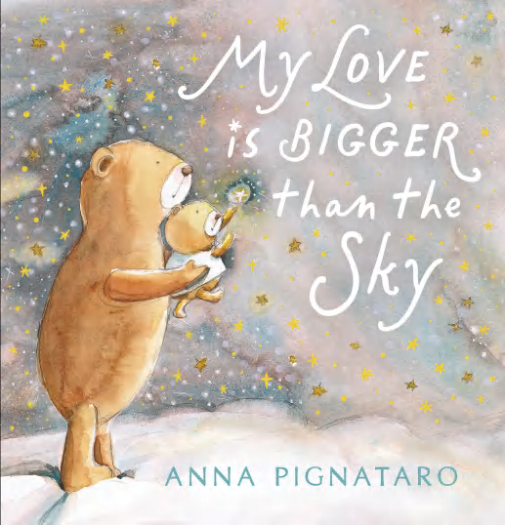

中文书名：《一直永远在一起》
英文书名：ALWAYS, TOGETHER, FOREVER SERIES
作 者：Anna Pignataro
出 版 社：Scholastic Aus
代理公司：Scholastic Aus
页 数：32页
出版时间：2026年3月
代理地区：全球版权（除ANZ）
审读资料：电子稿
类 型：儿童故事绘本

“妈妈，你有多爱我？”
“我爱你，胜过全世界，胜过世间万物。”
畅销书作家安娜・皮尼亚塔罗全新暖心之作
父母之爱，比天空更大，比岁月更长，献给父母与孩子，诉说无尽的爱与陪伴
爆款系列《一直如此》《在一起》《永远》《妈妈，你会爱我多久》续作，延续亲子深情主题
知名畅销书作家、插画师安娜・皮尼亚塔罗系列新作：1998 年获克莱顿插画奖，1999 年入围澳大利亚儿童图书委员会（CBCA）年度绘本，2020 年凭《鲸鱼之心》获国际儿童绘本大奖

核心卖点：

·畅销书作家口碑新作，品质保证：由知名畅销书作家、插画师安娜・皮尼亚塔罗创作，延续一贯温暖治愈风格。
·“一直永远在一起” 系列暖心续作，备受期待：爆款系列《一直如此》《在一起》《永远》《妈妈，你会爱我多久》续作，延续亲子深情主题。
·文字温柔戳心，诉说无尽爱意：文字细腻动人，精准表达父母对孩子无限、无条件的爱，直击内心，温暖治愈。
·插画梦幻唯美，阅读充满仪式感：画面温馨治愈、唯美动人，适合睡前、节日、纪念日共读，珍藏亲子时光。
·全年龄适用，温暖代代相传：从新生儿到曾祖父母，每一个人都能在书中感受到爱与被爱的美好，适合全家传承阅读。

系列介绍：

第一册：《一直如此》（ALWAYS）（32页，2006年）

“Mamma, how long will you love me?”
“Always.” Mamma smiled.
“How long is always?” Oli asked....
as magic as a starry night ...as wild as a windy day ...as wondrous as a winter snow ...as tricky as an autumn mist ...as soft as a cloudy sky ...

Like small children the world over, Oli the baby bear wants confirmation of his mother’s love. But when she assures him she will love him always, Oli has no concept of what she means.
“How long is always?” he wants to know. With the tender patience and wise imagination of a loving parent, mother bear explains ...
Focusing on the realities of the world around us, mother bear leads Oli gently through a series of landscapes, emphasising the magic and wonder of small everyday moments, and revealing the eternity inherent in them.

第二册：《在一起》（TOGETHER）（32页，2009年）

Over a rickety bridge Oli asked, “Mamma, will you hold my hand?” “I'll hold your hand and you'll hold mine and we'll go everywhere together.” said Mamma. Like small children the world over, Oli the baby bear wants confirmation of his mother's love. With the tender patience and wise imagination of a loving parent, mother bear explains . . .

Focusing on the realities of the world around us, mother bear leads Oli gently through a series of landscapes, emphasising the magic and wonder of small everyday moments of togetherness between parents and children.

第三册：《永远》（FOREVER）（32页，2012年）

Out in the fi elds with Mamma one day, Oli finds a cocoon. Oli asks what it is and what it will become, which leads to questions about the way things change every day in the world. Through their journey, Mamma and Oli experience many wonderful changes and witness the cocoon turn into a butterfl y. When Oli asks if he will change, Mamma says: You will become big and strong, whispered Mamma. But you will be my little bear forever.

第四册：《妈妈，你会爱我多久》（Mummy, How long will you love me?）（32页，2024年）

Underneath a big old elm, Oli asked, “Mummy, how long will you love me?”
“Always,” Mummy smiled.

Like small children the world over, Oli the baby bear wants confirmation of his mother’s love. But when she assures him she will love him always, Oli has no concept of what she means. “How long is always?” he wants to know.

With the tender patience and wise imagination of a loving parent, mother bear explains...

第五册：《我的爱，比天空更大》（My Love is Bigger than the Sky）（32页，2026年）

In the brambly forest Oli asked, “Mummy, how much do you love me?”

“More than the whole world and everything in it,” said Mummy.
From best-selling author and illustrator, Anna Pignataro, comes a tender-hearted story about infinite love.

作者简介：

Anna Pignataro is the acclaimed, best-selling author and illustrator of Always and the ‘Princess and Fairy’ series. Anna was the joint winner of the Crichton Award for book illustration in 1998 and shortlisted for CBCA Picture Book of the Year in 1999. Her picture book The Heart of a Whale was named the winner of the International Book Award for Children’s Picture Books, 2020. Anna lives in Victoria with her husband and daughter.

内页插图：

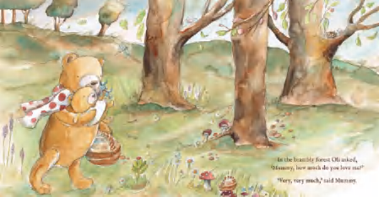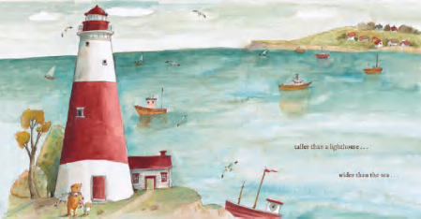

请将反馈信息发至：版权负责人
Email：Rights@nurnberg.com.cn
安德鲁·纳伯格联合国际有限公司北京代表处
北京市海淀区中关村大街甲59号中国人民大学文化大厦1705室, 邮编：100872
电话：010-82504106, 传真：010-82504200
公司网址：http://www.nurnberg.com.cn
书目下载：http://www.nurnberg.com.cn/booklist_zh/list.aspx
书讯浏览：http://www.nurnberg.com.cn/book/book.aspx
视频推荐：http://www.nurnberg.com.cn/video/video.aspx
豆瓣小站：http://site.douban.com/110577/
新浪微博：安德鲁纳伯格公司的微博_微博 (weibo.com)
微信订阅号：安德鲁纳伯格联合国际北京代表处

