新 书 推 荐

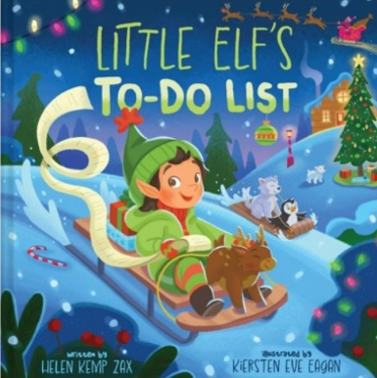
中文书名：《小精灵的待办清单》
英文书名：LITTLE ELF’S TO-DO LIST
作 者：Helen Kemp Zax
出 版 社：Abrams Appleseed
代理公司：Abrams/ANA
页 数：40页
出版时间：2026年9月
代理地区：中国大陆、台湾
审读资料：电子稿
类 型：故事绘本

- 精妙文案：内容温馨讨喜、贴近日常，全年都适合大声诵读。
- 轻度教育切入点：以趣味十足的形式展现列清单的行为习惯，契合该年龄段儿童执行功能的发展特点。
- 创意亮点：封面缀有璀璨闪粉；书末设有大幅拉页，呈现一份已完成的待办清单，清单上每一项均由小精灵用专属魔法墨水勾选完毕。
- 全新系列续作：继《小女巫》（Little Witch）《小兔子》（Little Bunny）后，本书为该热门优质系列的第三部作品。系列新作《小矮妖》（Little Leprechaun）将于 2027 年秋季推出！

内容简介：

Pile sleigh mile high with presents / Make Rudolph’s red nose glow

Sing joyful Christmas carols / Cheer Santa’s, “Ho ho ho!”

Little Elf is very busy from morning to night―and a to-do list is a huge help! From baking cookies to wrapping presents to packing the sleigh and celebrating takeoff, this Elf has many tasks to complete before bedtime. But it’ll all get done; one thing at a time. And when all the tasks are finally completed, Little Elf is rewarded with a fantastically finished list and a sweet good-night kiss from Mrs. Claus.

Perfect for Christmas or everyday read-alouds, Little Elf’s To-Do List offers a gentle lesson on the importance of organization. The sparkly glitter stamped on the front cover is so inviting that young readers will be eager to go on this Christmas Eve adventure with Little Elf, and they are in for another sparkly surprise when they unfold a secret flap at the end of the book to see all the items checked off the to-do list in magical ink!

作者简介：


Helen Kemp Zax could spend all day musing over rhymes, so daily to-do lists keep her life on track. Her poetry has appeared in many anthologies and magazines, and she was co-awarded the 2021 YorkMix International Children’s Poetry Prize and won the 2018 Middle Grade Katherine Paterson Prize. A former lawyer and teacher, Kemp Zax holds an MFA in writing from Vermont College of Fine Arts. She lives in Washington, D.C., with her husband, Leonard, and their Aussiedoodle, Huckleberry Finn.

Kiersten Eve Eagan is an illustrator working in children’s publishing and design for television and film. Eagan is passionate about storytelling and loves using design to help bring stories to life. She studied illustration at the Academy of Art in San Francisco and now lives in Vancouver, British Columbia, where she loves exploring the mountains or spending time by the sea.

内页插图：
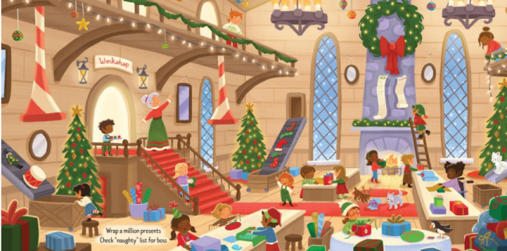
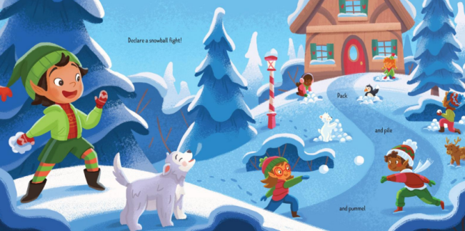

感谢您的阅读！
请将反馈信息发至：版权负责人
Email：Rights@nurnberg.com.cn
安德鲁·纳伯格联合国际有限公司北京代表处
北京市海淀区中关村大街甲59号中国人民大学文化大厦1705室, 邮编：100872
电话：010-82504106, 传真：010-82504200
公司网址：http://www.nurnberg.com.cn
书目下载：http://www.nurnberg.com.cn/booklist_zh/list.aspx
书讯浏览：http://www.nurnberg.com.cn/book/book.aspx
视频推荐：http://www.nurnberg.com.cn/video/video.aspx
豆瓣小站：http://site.douban.com/110577/
新浪微博：安德鲁纳伯格公司的微博_微博 (weibo.com)
微信订阅号：ANABJ2002


