新 书 推 荐

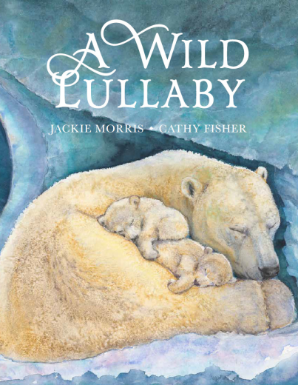
中文书名：《野性摇篮曲》
英文书名：A Wild Lullaby
作 者：Jackie Morris, Cathy Fisher
出 版 社：Otter Barry Books
代理公司：DHA/ANA
页 数：40页
出版时间：2026年9月
代理地区：中国大陆、台湾
审读资料：电子稿
类 型：故事绘本

卖点：
一曲野性摇篮曲，伴全世界的小生命安然入眠
写给孩子的自然晚安诗，温柔狂野的睡前童话

内容简介：

“The time has come at close of day to seek and find the quiet adventures of sleep... Let me sing to you, my Child, a lullaby, gentle, wild.”
A mother sings to her child, evoking the ways in which wild creatures across the world are also lulling their babies to sleep—whales in the sea, fledgling ospreys in their nest, bear cubs in their ice den, seals on the shore, ponies on the heath, the snow leopard family in the high rocks, and tigers in the deepest jungle.
The lyrical story is enriched by Cathy Fisher’s exquisite paintings of each scene, realistic yet magical. Together they create a rare sense of tenderness and peace across our wild world.

作者简介：

Jackie Morris is an award-winning writer and illustrator. She lives and works in Wales and her work is informed and inspired by wild places and creatures. She has illustrated over 40 books, and was shortlisted for the CILIP Kate Greenaway Medal in 2016 for Something About a Bear. She won it in 2019 for The Lost Words. She was nominated for the Hans Christian Andersen Award in 2024 in the illustrator category.

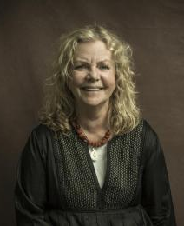
Cathy Fisher is an artist, illustrator and picture book maker renowned for her sensitive and delicate depictions of childhood, animals and the natural world. Two of Cathy’s books have been longlisted for the Kate Greenaway Medal.

感谢您的阅读！
请将反馈信息发至：版权负责人
Email：Rights@nurnberg.com.cn
安德鲁·纳伯格联合国际有限公司北京代表处
北京市海淀区中关村大街甲59号中国人民大学文化大厦1705室, 邮编：100872
电话：010-82504106, 传真：010-82504200
公司网址：http://www.nurnberg.com.cn
书目下载：http://www.nurnberg.com.cn/booklist_zh/list.aspx
书讯浏览：http://www.nurnberg.com.cn/book/book.aspx
视频推荐：http://www.nurnberg.com.cn/video/video.aspx
豆瓣小站：http://site.douban.com/110577/
新浪微博：安德鲁纳伯格公司的微博_微博 (weibo.com)
微信订阅号：ANABJ2002


