新 书 推 荐
《了不起的奥古斯都》
THE AMAZING AUGUSTUS

中文书名：《了不起的奥古斯都》
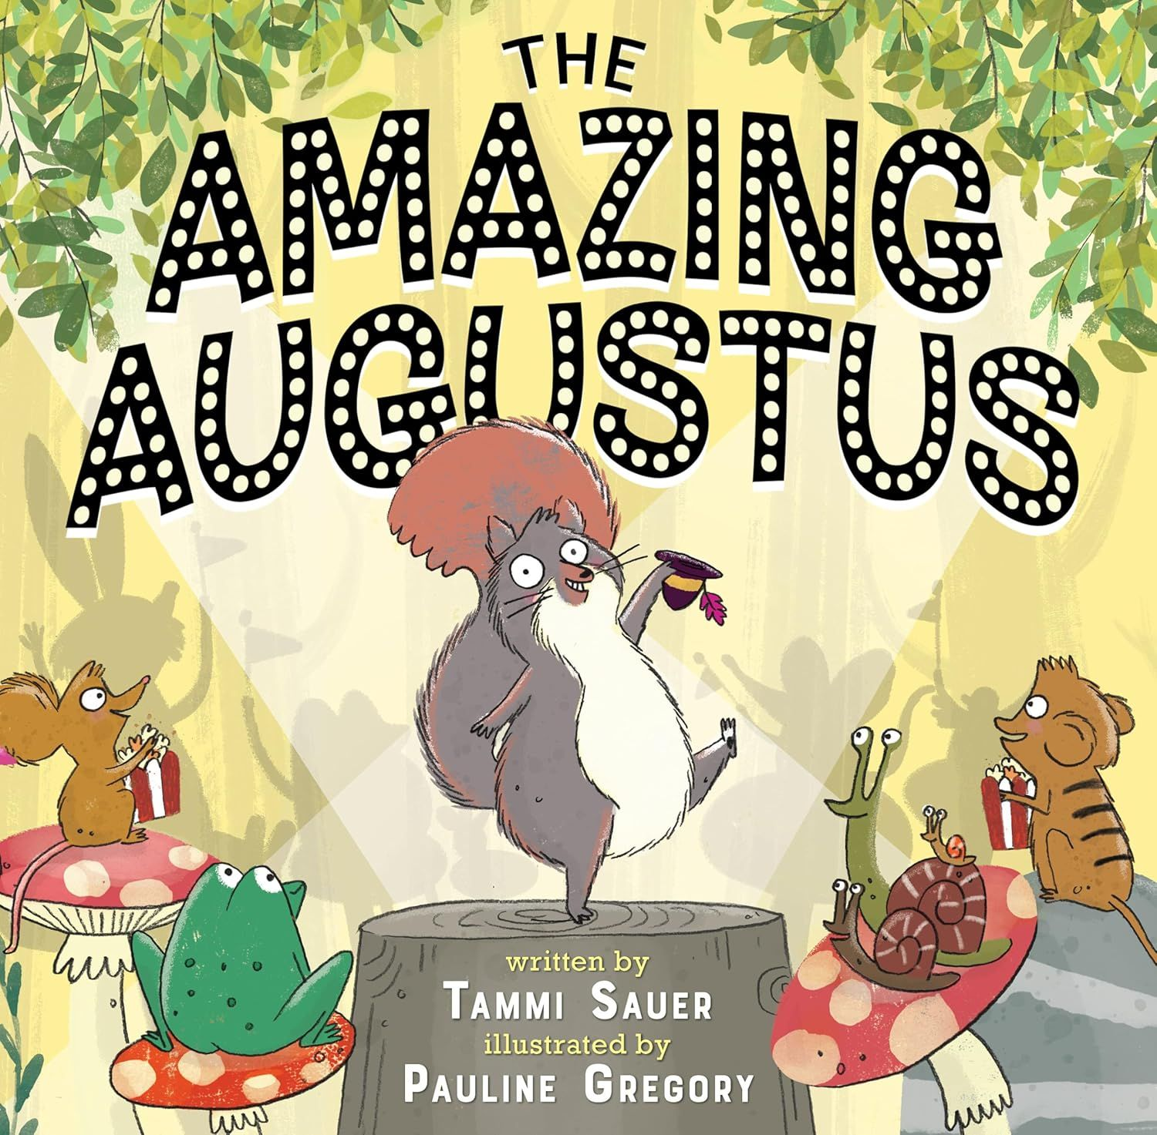
英文书名：THE AMAZING AUGUSTUS
作 者：Tammi Sauer
插 画 师：Pauline Gregory
出 版 社：Disney Hyperion
代理公司：Defiore
页 数：40页
出版时间：2026年5月
代理地区：中国大陆、台湾
审读资料：电子稿
类 型：3-5岁故事绘本

以爆笑故事，教会孩子谦逊与反思
幽默爆笑+感官启蒙+权威书评加持，以傲娇小松鼠的冒险，传递谦逊理念，适配3-5岁儿童，迪士尼出版品质保障，自带续集伏笔
作者Tammi Sauer出版30本绘本，另有多部作品即将推出，作品已被翻译成意大利语、西班牙语、韩语、中文和法语
作者著作《小鸡舞》《你的外星人》和《 Nugget & Fang》被改编为音乐剧，在全国巡演；《话多的小鸟》被评为“儿童独立阅读推荐书目”、2021年“俄克拉荷马州全民阅读”精选图书，以及班克街学院年度最佳图书；《你的外星人》作为美国国家公共广播电台年度最佳图书

本书卖点：

·权威书评加持：获《科克斯评论》好评，称赞插画色彩饱满、细节充满幽默，狮子的不适与夸张打嗝场景刻画出色，是一场充满感官体验与趣味的阅读之旅。

·风格幽默吸睛：以傲娇小松鼠的自我炫耀为核心，情节滑稽有趣，融入肢体幽默，贴合低幼儿童阅读喜好，让孩子全程欢笑，同时适合大声朗读。

·互动感十足：孩子能提前发现小松鼠的危险，形成“读者比主角聪明”的趣味互动，增强阅读参与感，提升阅读兴趣。

·内核正向易懂：通过小松鼠因骄傲自满陷入困境的故事，潜移默化传递“谦逊”的理念，引导孩子反思自我，避免盲目自大，兼具趣味性与教育性。

·创作团队优质：作者是资深儿童文学作家，出版多部优质绘本，部分作品改编为音乐剧全国巡演，口碑与销量双保障；插画师风格独特，擅长用传统材料打造可爱又有童趣的画面。

媒体评价：

"Gregory’s digitally edited multimedia illustrations burst with color and humor in the details....The depictions of the lion’s discomfort and oversize burp are especially impressive. A giggly exploration of the senses, with a dash of bodily humor."—Kirkus Reviews

内容简介：

A picture book about Augustus, a hubristic squirrel who is so busy celebrating himself that he winds up in the belly of a lion

Behold, my lovely audience!

I am the amazing Augustus.

There is no one quite like me.

Augustus the squirrel is so busy praising himself that he winds up in the belly of a lion! This quirky, voicy picture book by beloved author Tammi Sauer is certain to have kids laughing as they realize well before Augustus that he is walking across a lion’s back. Kids love being smarter than the book, and this one takes the joke as far as possible—that is, literally inside a lion. Stay tuned for Augustus’s next adventure: AUGUSTUS IS BACK! (YOU’RE WELCOME!)

作者简介：

Tammi Sauer, a former teacher and library media specialist, is a full-time children's book author. She has 30 picture books with more on the way. In addition to winning awards and earning starred reviews, Tammi's books have gone on to do great things. Chicken Dance, Your Alien, and Nugget & Fang were made into musicals that toured the nation. Wordy Birdy was named a Kids’ Indie Next List book, the 2021 Book Choice for Read Across Oklahoma, and a Bank Street College Best Book of the Year. And Your Alien, an NPR Best Book of the Year, was released in Italian, Spanish, Korean, Chinese, and French which makes her feel extra fancy.

插画师简介：

Pauline Gregory is an award-winning children’s illustrator, graduating from Arts University Plymouth. Drawing is the quiet place she loves to be. With silliness and humor at her core, she loves to make the reader laugh. Living and working in north Cornwall, England, Pauline creates quirky illustrations with humour and charm using traditional materials.

请将反馈信息发至：版权负责人
Email：Rights@nurnberg.com.cn
安德鲁·纳伯格联合国际有限公司北京代表处
北京市海淀区中关村大街甲59号中国人民大学文化大厦1705室, 邮编：100872
电话：010-82504106, 传真：010-82504200
公司网址：http://www.nurnberg.com.cn
书目下载：http://www.nurnberg.com.cn/booklist_zh/list.aspx
书讯浏览：http://www.nurnberg.com.cn/book/book.aspx
视频推荐：http://www.nurnberg.com.cn/video/video.aspx
豆瓣小站：http://site.douban.com/110577/
新浪微博：安德鲁纳伯格公司的微博_微博 (weibo.com)
微信订阅号：安德鲁纳伯格联合国际北京代表处

