新 书 推 荐
《愤怒的小海龟》
FURIOUS TURTLE

中文书名：《愤怒的小海龟》
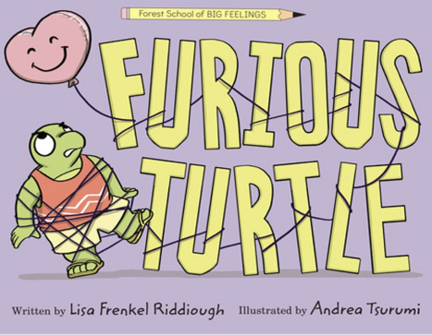
英文书名：FURIOUS TURTLE
作 者：Lisa Frenkel Riddiough
插 画 师：Andrea Tsurumi
出 版 社：Disney Hyperion
代理公司：Defiore
页 数：32页
出版时间：2026年7月
代理地区：中国大陆、台湾
审读资料：电子稿
类 型：3-7岁故事绘本

系列续作+情绪管理，贴合儿童真实挫折场景
传递“优雅面对失败、化解愤怒”的理念，适配3-7岁儿童，迪士尼出版品质保障
作者Lisa Frenkel Riddiough的《赖以生存的信》获得《学校图书馆期刊》星级评论，《馅饼海盗》被《科克斯评论》称赞为“藏着宝藏的佳作”
插画师Andrea Tsurumi第一本书《意外！》被评为美国国家公共广播电台精选读物；第二本书《螃蟹蛋糕》荣获红三叶草图书奖；《我来啦！》作为“大象与小猪”系列衍生读物，被《科克斯评论》和《父母杂志》共同评为年度最佳图书

本书卖点：

·系列优势凸显：作为《森林学校的大情绪》系列第二部，延续系列情绪启蒙核心，自带系列读者基础，衔接前作调性，易吸引原有读者群体。

·主题贴合需求：聚焦“愤怒”这一儿童常见负面情绪，以校园嘉年华的挫折场景为载体，精准戳中孩子“努力却失败”的成长痛点，易引发情感共鸣。

·教育意义突出：不仅引导儿童认识、接纳自身的愤怒情绪，更传递“优雅面对失败”“主动化解负面情绪”的方法，是家长和教育者引导孩子情绪管理的实用工具。

·创作团队优质：作者作品获《学校图书馆期刊》星级评论、《科克斯评论》好评，创作经验丰富；插画师作品屡获权威认可，画风灵动，贴合故事温暖治愈基调。

·品质保障过硬：由Disney Hyperion（迪士尼海波龙出版社）出版，制作规格高，内容优质有保障，适配校园、家庭等多场景阅读。

内容简介：

When everything goes wrong for Turtle during the school carnival, he becomes shell-shakingly furious. How will he get through the rest of this obnoxious day?

This second book in the Forest School of Big Feelings series from Lisa Frenkel Riddiough and Andrea Tsurumi offers a relatable look at tackling big feelings, losing with grace, and discovering your own calm in the face of chaos.

The carnival was just beginning. Turtle had grand plans for winning!

He tried to hit the striker bell but accidentally whacked his shell.

From arcade games to the beanbag toss, Turtle’s fury grew with each upsetting loss. What is Turtle to do when his fishing pole breaks, he isn't the winner of the drawing contest, his number isn't chosen during the prize walk, and the arcade machine won't accept his token?

He gets frustrated, flabbergasted, and, of course, furious!

But with help from his teacher Ms. Bunny, Turtle learns how to transform his anger into peace.

作者简介：

Lisa Frenkel Riddiough is the author of LETTERS TO LIVE BY, which School Library Journal called, “Creative, humorous, and thought-provoking,” in a starred review. Of her second book, PIE-RATS!, Kirkus said, “Here be treasure!” Lisa is a graduate of Hamline University’s MFAC program in writing for children and young adults, and splits her time between Northern California and Idaho. Learn more at lisariddiough.com.

插画师简介：

Andrea Tsurumi is an author, illustrator, and cartoonist. Their first book, ACCIDENT!, was named an NPR Great Read, and their second, CRAB CAKE, won the Red Clover Book Award. I’M ON IT!, an Elephant & Piggie Like Reading Book, which was named both a Kirkus and Parents Magazine best book of the year. Andrea lives in Philadelphia with their spouse and very serious dog. Learn more at AndreaTsurumi.com.

请将反馈信息发至：版权负责人
Email：Rights@nurnberg.com.cn
安德鲁·纳伯格联合国际有限公司北京代表处
北京市海淀区中关村大街甲59号中国人民大学文化大厦1705室, 邮编：100872
电话：010-82504106, 传真：010-82504200
公司网址：http://www.nurnberg.com.cn
书目下载：http://www.nurnberg.com.cn/booklist_zh/list.aspx
书讯浏览：http://www.nurnberg.com.cn/book/book.aspx
视频推荐：http://www.nurnberg.com.cn/video/video.aspx
豆瓣小站：http://site.douban.com/110577/
新浪微博：安德鲁纳伯格公司的微博_微博 (weibo.com)
微信订阅号：安德鲁纳伯格联合国际北京代表处

