新 书 推 荐

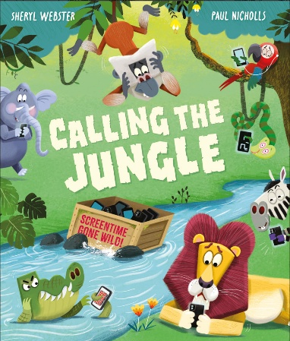
中文书名：《呼唤大丛林》
英文书名：CALLING THE JUNGLE
作 者：Sheryl Webster and Paul Nicholls
出 版 社：OUP
代理公司：ANA
页 数：32页
出版时间：2027年3月
代理地区：中国大陆、台湾
审读资料：电子稿
类 型：儿童故事绘本

- 童趣故事妙趣横生，轻松俘获孩子喜爱：以丛林小动物为主角，演绎全员沉迷电子屏幕的搞笑日常，情节鲜活有趣、桥段轻松诙谐，没有生硬说教，用好玩的故事牢牢吸引孩子的阅读兴趣。
- 紧扣现实热门话题，自带优质启蒙意义：聚焦当下普遍存在的 “电子屏幕依赖” 问题，温柔探讨科技对生活的影响，引导孩子思考人与电子产品的相处方式，帮助孩子从小树立规则意识，学会合理把控用屏时间。

- 动物形象拟人可爱，神态动作鲜活生动：书中狮子、猴子等丛林动物全部做了拟人化设计，造型圆润软萌，线条简洁流畅，非常符合低龄儿童的审美。画师尤其擅长捕捉生动神态：动物们低头紧盯屏幕时入迷的模样、丢失设备后慌张无措的样子、重拾自然生活后轻松愉悦的状态，都刻画得惟妙惟肖，单看画面就能读懂角色情绪。
- 适用场景广泛，亲子共读、课堂分享皆宜：故事篇幅适中、语言简单浅白、寓意直白易懂，既适合居家亲子共读、睡前伴读，也可作为幼儿园、低年级课堂的话题素材，方便开展集体交流与主题讨论。

内容简介：

SCREEN TIME GOES WILD IN THIS FUNNY AND TIMELY PICTURE BOOK ABOUT THE IMPACT OF TECHNOLOGY

Following a storm, Joey the monkey finds a box of ‘sparkle screens’ washed up in the jungle.

Before long, the devices quickly begin to replace the animals’ usual routine and habits. Lion no longer roars his morning wake-up call—instead, the animals all just set an alarm on their ‘sparkle screen’; the monkeys no longer swing through the trees playing—instead they sit and play games on their devices. The animals spend most of their time taking selfies, listening to music instead of making it, and accidents start to happen because they are too busy looking at their screens.

Deciding that enough is enough, one night Joey collects up all of the devices and sends them down the river in a box. The next morning, the animals panic at first without their screens, but as life returns to the jungle the animals realise that they are so much happier without the strange rectangles in their lives.

• A modern and funny take on the role of technology our lives.

• This story exploring the impact of screen time is ideal for prompting early discussions about our relationship with technology and the need for setting boundaries.

• Relatable topic for children who see the adults in their lives using devices, even if they are not yet using them themselves.

• The humour of Sheryl Webster’s timely tale is perfectly captured by Paul Nicholls’ witty illustrations.

作者简介：

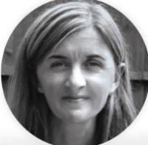
Sheryl Webster studied Psychology and English and then taught in primary schools. Her first published picture book was released during a career break to have her first child, and she now has over 40 titles published worldwide. She is the author of One Little Bird. Sheryl has four children and lives in Liverpool.


Paul Nicholls graduated with a BA Hons Degree from the North Wales School of Art and Design in 2000. He has produced illustrations for advertising, editorial, greetings cards, and books. Paul lives on the coast of Mid Wales, where he shares a studio with his partner and fellow illustrator, Melanie Mitchell.

内页插图：
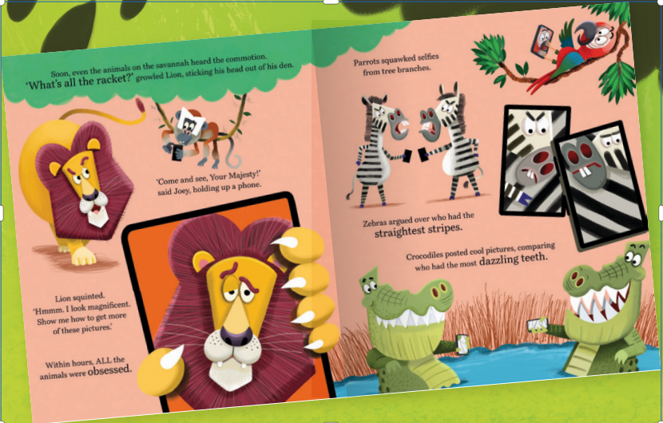
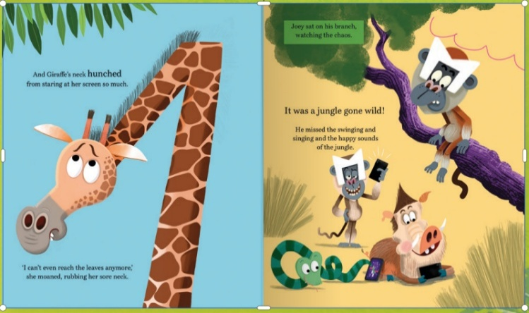

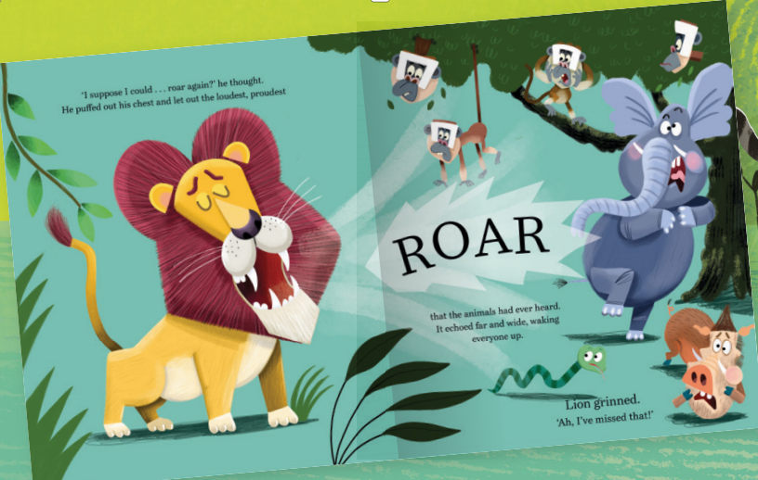

感谢您的阅读！
请将反馈信息发至：版权负责人
Email：Rights@nurnberg.com.cn
安德鲁·纳伯格联合国际有限公司北京代表处
北京市海淀区中关村大街甲59号中国人民大学文化大厦1705室, 邮编：100872
电话：010-82504106, 传真：010-82504200
公司网址：http://www.nurnberg.com.cn
书目下载：http://www.nurnberg.com.cn/booklist_zh/list.aspx
书讯浏览：http://www.nurnberg.com.cn/book/book.aspx
视频推荐：http://www.nurnberg.com.cn/video/video.aspx
豆瓣小站：http://site.douban.com/110577/
新浪微博：安德鲁纳伯格公司的微博_微博 (weibo.com)
微信订阅号：ANABJ2002


