新 书 推 荐


中文书名：《有一百万个屁的沙发》
英文书名：THE COUCH OF A MILLION FARTS
作 者：Mark Sweeney and Jennifer Harney
出 版 社：Little Brown
代理公司：ANA
页 数：40页
出版时间：2027年1月
代理地区：中国大陆、台湾
审读资料：电子稿
类 型：故事绘本

- 爆笑情节天马行空，轻松戳中孩子笑点：一张神奇的沙发接纳了各种各样的屁股，也储存了千奇百怪的屁——喇叭声、嘟嘟声、吱吱声，来自爷爷奶奶、生日会宾客，甚至圣诞老人的驯鹿！当沙发被撑到极限，一场“惊天动地”的释放大戏就此上演。故事荒诞幽默、毫无说教，只用脑洞大开的创意让孩子笑到停不下来。
- 巧妙化解生理尴尬，传递健康自然态度：聚焦“放屁”这个孩子既觉得好笑又容易害羞的话题，用有趣的故事告诉孩子：放屁是再正常不过的生理现象。同时，通过沙发“吸收—膨胀—释放”的夸张设定，轻松探讨“积累与宣泄”的朴素道理，引导孩子用平常心看待身体功能，消除羞耻感。
- 形象夸张动态十足，音效互动乐趣翻倍：沙发接缝处绷紧、小狗敏锐察觉时的神态、最后“一泻千里”的爆发场面，画风滑稽生动，极具画面冲击力。家长伴读时可以和孩子一起模仿各种屁声，制造欢乐的互动时刻。故事篇幅适中、语言简单活泼，既适合睡前哈哈一笑，也可作为幼儿园“身体认知”或“情绪释放”主题活动的趣味素材。
内容简介：
The titular couch supports all kinds of butts, and even more kinds of farts: trumpets, toots, and squeaks by everyone from grandparents and birthday party guests to even one of Santa's reindeer! But who could have guessed that the couch was absorbing every single fart? Now that it's bursting at the seams, there's only one thing left to do: let it rip!
作者简介：

Mark Sweeney is a writer, husband, and father of two. He’s spent 30 years in the advertising industry, writing commercials for some of the most iconic brands in the world. He now resides in Novato, CA with his family, writing children’s books and helping his wife Gina write children’s songs for her musical history YouTube channel. The Couch of a Million Farts is his debut.


Jennifer Harney has illustrated several picture books, including The Secret Life of Dog Toys by Kelly DiPucchio, This Is Not a Sleepy Bear Book by Brian Gehrlein, and How Dinosaurs Went Extinct: A Safety Guide by Ame Dyckman. She is the author and illustrator of There's a Pony in My Apartment!, Underwear! and Swim, Duck, Swim!. Jenn lives in Cleveland, Ohio, with her husband, her daughter, a corgi named Steve, and the ghost of the oldest living goldfish in North America.
内页插图：
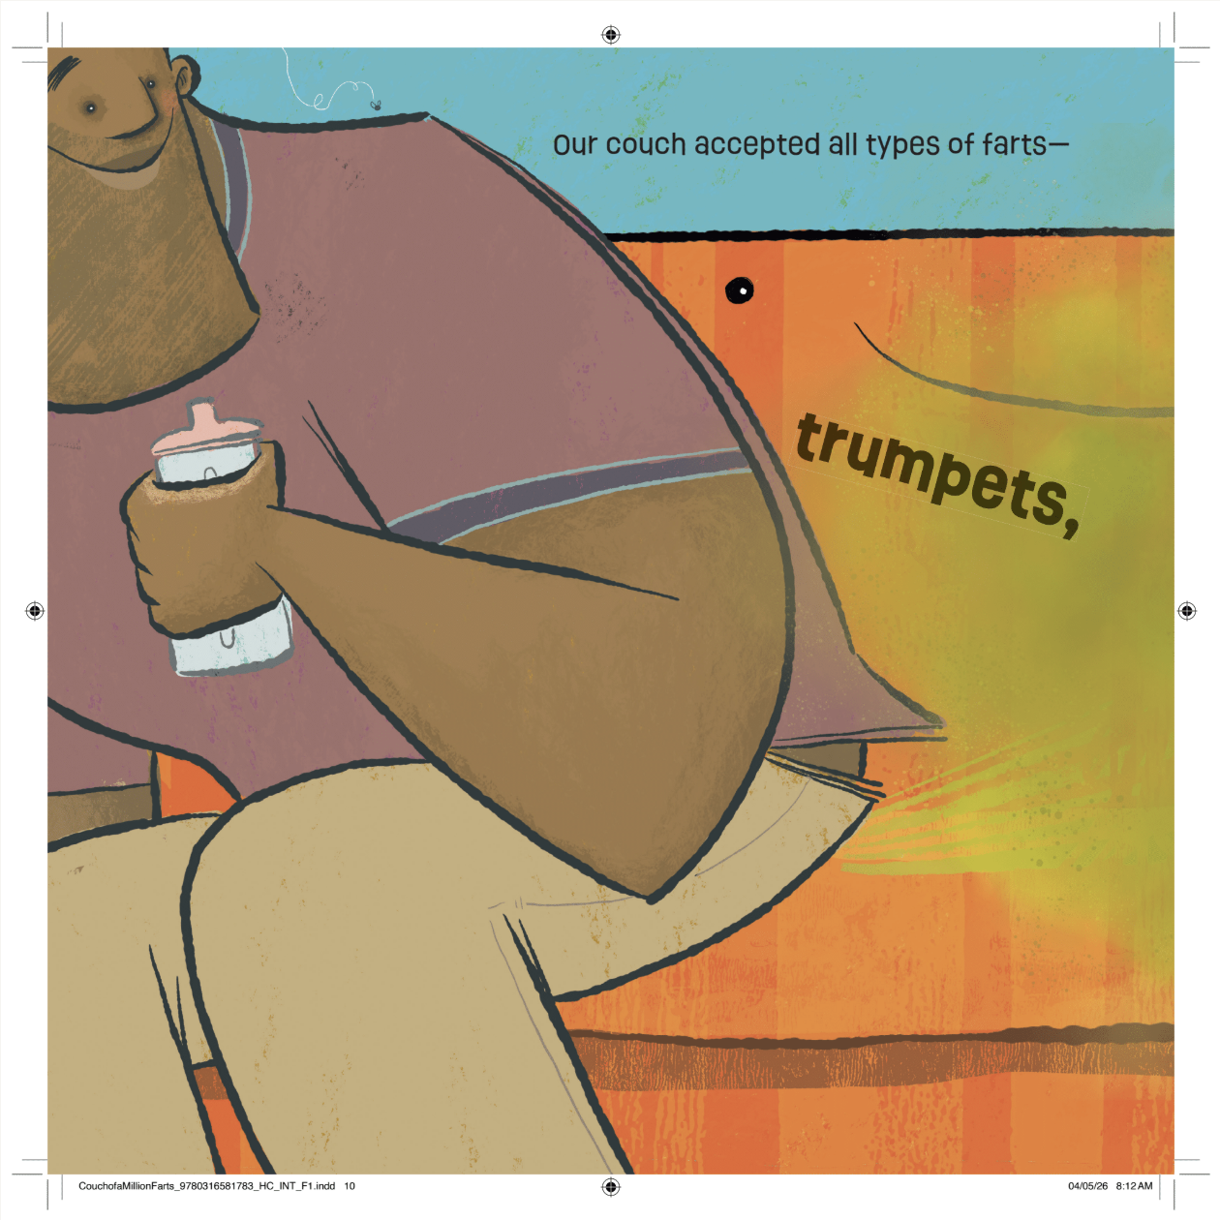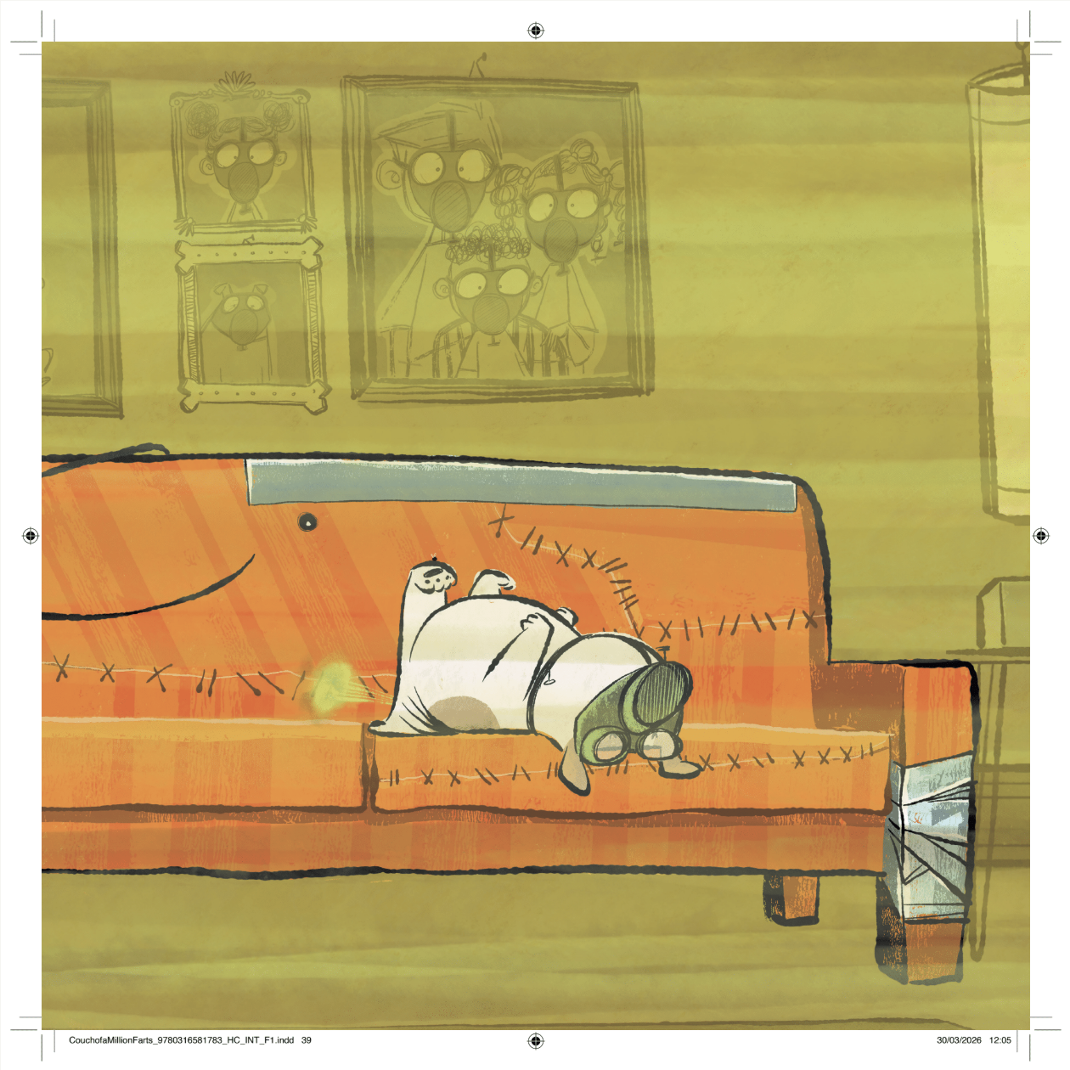
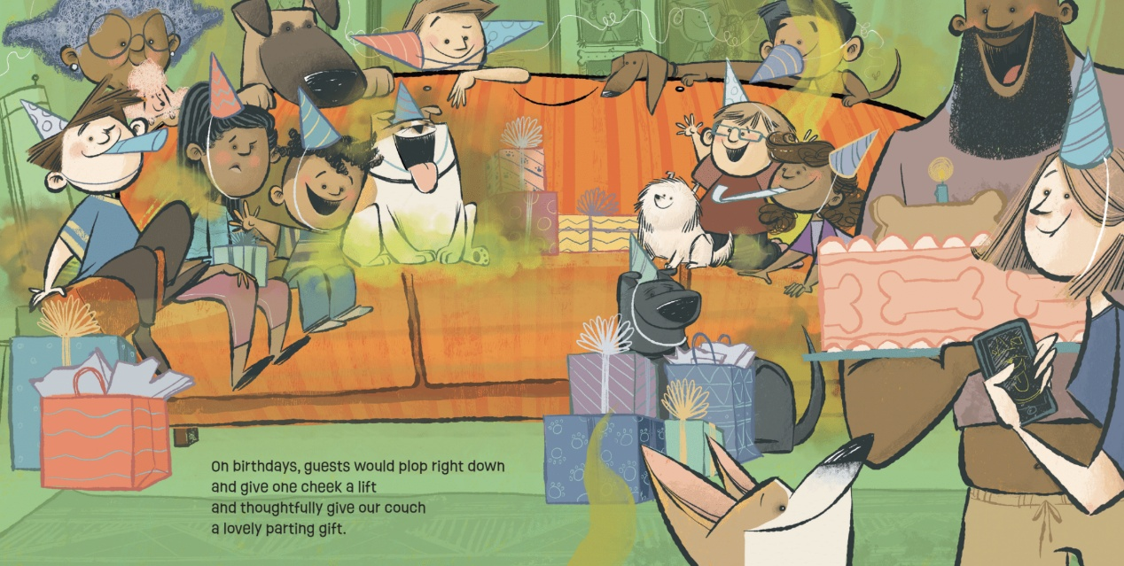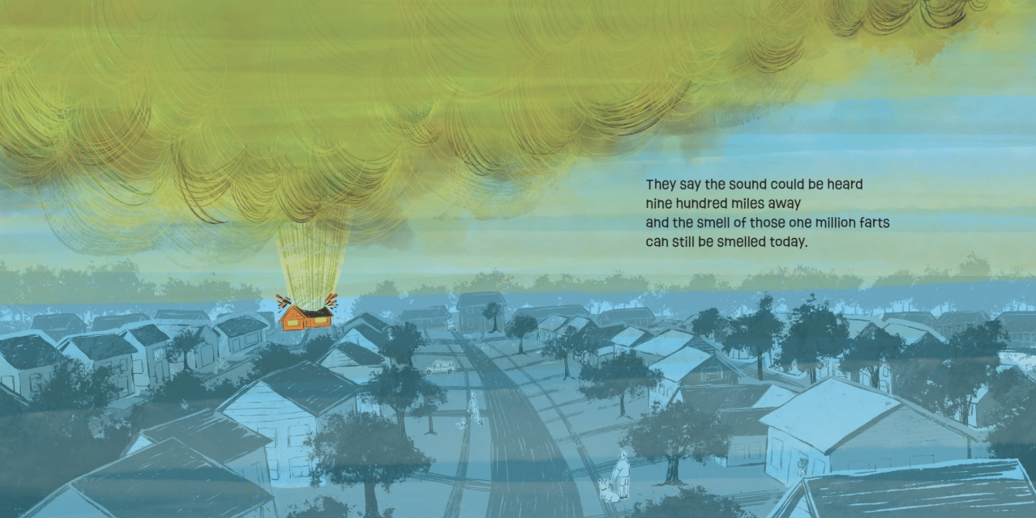
感谢您的阅读！
请将反馈信息发至：版权负责人
Email：Rights@nurnberg.com.cn
安德鲁·纳伯格联合国际有限公司北京代表处
北京市海淀区中关村大街甲59号中国人民大学文化大厦1705室, 邮编：100872
电话：010-82504106, 传真：010-82504200
公司网址：http://www.nurnberg.com.cn
书目下载：http://www.nurnberg.com.cn/booklist_zh/list.aspx
书讯浏览：http://www.nurnberg.com.cn/book/book.aspx
视频推荐：http://www.nurnberg.com.cn/video/video.aspx
豆瓣小站：http://site.douban.com/110577/
新浪微博：安德鲁纳伯格公司的微博_微博 (weibo.com)
微信订阅号：ANABJ2002


