系 列 推 荐
《战犬》系列（2册）
WAR DOG Series (2 books)
中文书名：《战犬》（第一册）
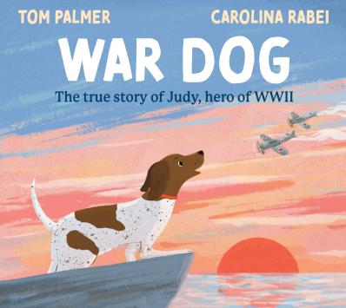
英文书名：WAR DOG
作 者：Tom Palmer
插 画 师：Carolina Rabei
出 版 社：Scholastic UK
代理公司：Scholastic UK
页 数：32页
出版时间：2025年8月
代理地区：中国大陆、台湾
审读资料：电子稿
类 型：故事绘本

【亮点解析】
一个根据二战真实事件改编、鼓舞人心的勇敢猫咪故事
《与幼儿共读的精彩绘本》——菲奥娜·夏普

内容简介：

“A brilliant book to explore with young children”----- Fiona Sharp

Judy is a dog who lives on a ship called HMS Grasshopper.

As the ship’s mascot, Judy has many duties.

She catches rats, watches out for soldiers who may fall overboard, and she listens out for danger.

内页插图：

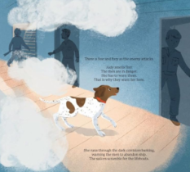

中文书名：《战猫》（第二册）
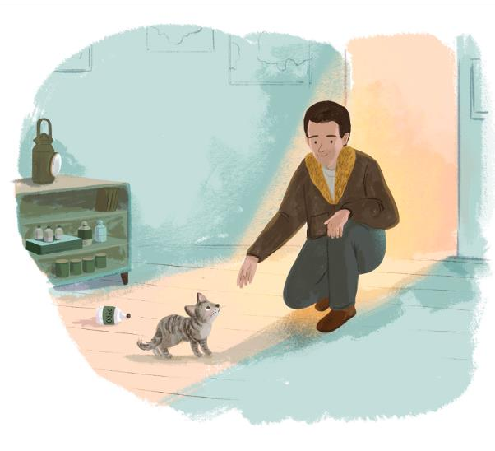
英文书名：WAR CAT
作 者：Tom Palmer
插 画 师：Carolina Rabei
出 版 社：Scholastic UK
代理公司：Scholastic UK
页 数：32页
出版时间：2027年9月
代理地区：中国大陆、台湾
审读资料：电子稿
类 型：故事绘本

核心卖点：

·获奖作家汤姆・帕尔默全新绘本作品，致敬二战真实英雄 —— 猫咪 “派洛”

·插画师卡罗莱娜・拉贝用细腻动人的画面，鲜活再现这段温暖故事

·书末附非虚构知识页，让孩子了解派洛与鲍勃在战争中的真实事迹

内容简介：

An inspiring story about a real cat’s bravery during World War Two.

"News spread of Pyro’s heroics.
Now, before any man flew on a mission,
they came to Pyro and stroked his soft warm fur.
They knew that Pyro was a lucky cat."

Pyro is a kitten living on the edge of a Scottish airfield during World War Two. One day, a plane gets too close and he scampers into a building. Here, he meets war photographer Bob Bird, and the two of them form a strong bond – he even flies with him!

But, during a dangerous and cold flight, can Pyro be brave and help Bob through the journey?

作者简介：

Tom Palmer is the award-winning author of over sixty books for children. Notably, he has written many titles to support children with dyslexia at Barrington Stoke. When not writing, he loves watching live sports, walking his dog Finn, and fell running. War Dog was his first picture book.

插画师简介：

Carolina Rabei was born in Moldova but now lives in the UK, where she graduated with a distinction in Children’s Book Illustration from the Cambridge School of Art. Her debut picture book, Snow, a poem written by Walter de la Mare, was nominated for the Kate Greenaway Medal.

内页插图：

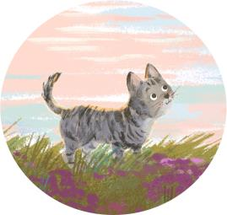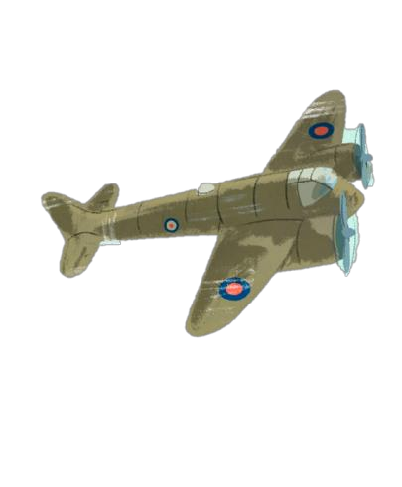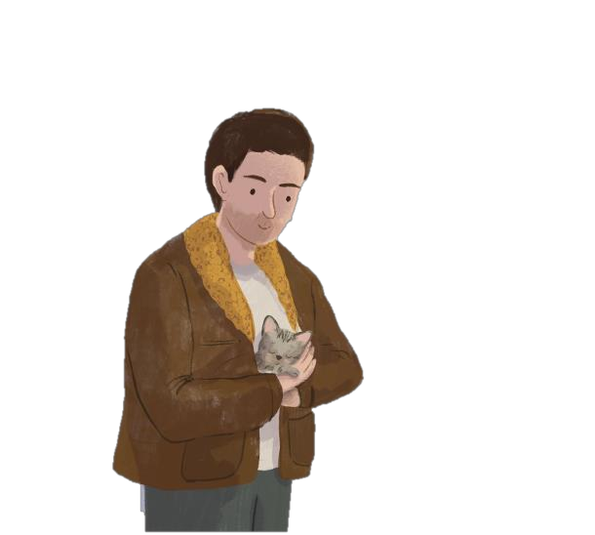

请将反馈信息发至：版权负责人
Email：Rights@nurnberg.com.cn
安德鲁·纳伯格联合国际有限公司北京代表处
北京市海淀区中关村大街甲59号中国人民大学文化大厦1705室, 邮编：100872
电话：010-82504106, 传真：010-82504200
公司网址：http://www.nurnberg.com.cn
书目下载：http://www.nurnberg.com.cn/booklist_zh/list.aspx
书讯浏览：http://www.nurnberg.com.cn/book/book.aspx
视频推荐：http://www.nurnberg.com.cn/video/video.aspx
豆瓣小站：http://site.douban.com/110577/
新浪微博：安德鲁纳伯格公司的微博_微博 (weibo.com)
微信订阅号：安德鲁纳伯格联合国际北京代表处

