新 书 推 荐
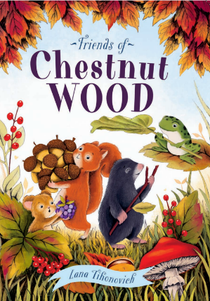
中文书名：《栗树林的伙伴们》
英文书名：FRIENDS OF CHESTNUT WOOD
作 者：Lana Tihonovich
出 版 社：Scholastic UK
代理公司：Scholastic UK/ANA
页 数：32页
出版时间：2027年3月
代理地区：中国大陆、台湾
审读资料：电子稿
类 型：故事绘本
版权已授：法国、意大利

法国版权已预先售出，意大利版权在英国出版前通过拍卖售出
- 这是拉娜·蒂霍诺维奇（Lana Tihonovich）的首部绘本佳作。她以细腻笔触打造出一个唯美治愈的林间秘境，令人沉醉不已。
- 全书插画刻画极致精巧，栩栩如生的森林小动物灵动可爱，处处流淌着温暖治愈的怀旧气息。
- 故事温情满满、妙趣横生，既是一曲献给大自然的美好赞歌，也能鼓励孩子们走出家门，用心探寻身边多姿多彩的自然世界。
- 故事饱含深刻寓意：歌颂纯粹的友谊，教会孩子遇事多动脑筋、善用身边之物，也娓娓讲述了争吵过后如何握手言和。这份温暖的内涵，能够引发大小读者的强烈共鸣，赢得家长与孩子们的共同喜爱。
内容简介：
Deep in Chestnut Wood lived four dear friends: a mouse, a squirrel, a mole and a frog. They always looked out for one another and happily shared their food. One crisp autumn morning, the mouse wandered out for a stroll and chanced upon a cracked porcelain cup. Curious and confused about what it could be, she called over her pals to take a look. Each little animal came up with a different idea of what to do with it.
The frog announced he wanted to claim the cup as his very own bathtub, which instantly ruffled the others’ feathers. A quarrel broke out, and tempers flared. For the first time ever, the peaceful harmony of Chestnut Wood was broken.
The wise mole stepped forward and suggested they return the cup to where it was found, for it had only brought strife between them. His words settled the dispute, and the friends made peace once more. Side by side, they enjoyed the passing seasons through spring, summer, autumn and winter.
Then one wild night, a fierce storm swept through the wood. Trees toppled and broken branches littered the ground. Two birds’ nests were torn apart, though thankfully, the eggs inside stayed safe. The four friends soon hatched a clever plan: they used the old porcelain cup to build a brand-new nest for the pair of birds.
The birds chirped merrily in their new home, and the four friends beamed with joy. Working together, they had turned a discarded trinket into something truly precious and useful.
作者简介：

Lana Tihonovich is a self-taught children’s book illustrator based in the picturesque city of Gdańsk, Poland. From a young age, her passion for drawing shone through, earning her top prizes in art competitions. After a brief pause from her craft, she rediscovered her love for illustration, diving deeply into the whimsical and comforting world of children’s stories.
Her illustrations evoke a sense of cozy nostalgia, blending vibrant colours, rich textures, and endearing characters that transport viewers into heartwarming, magical worlds. Inspired by nature, history, and the charm of everyday moments, Lana’s art invites you into a world where imagination and memory intertwine. In her spare time, she enjoys watching period dramas, knitting, and exploring the historic streets of Gdańsk, drawing inspiration from the timeless beauty around her.
Lana’s work beautifully captures the warmth and wonder of childhood, offering a visual escape into enchanting stories filled with joy, imagination, and the comforting glow of nostalgia.
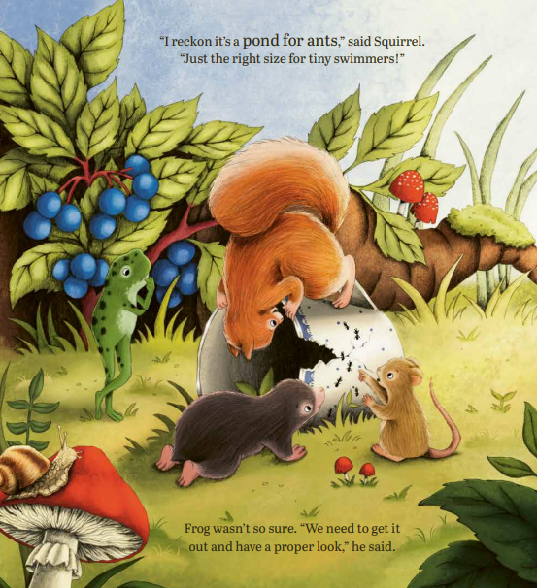
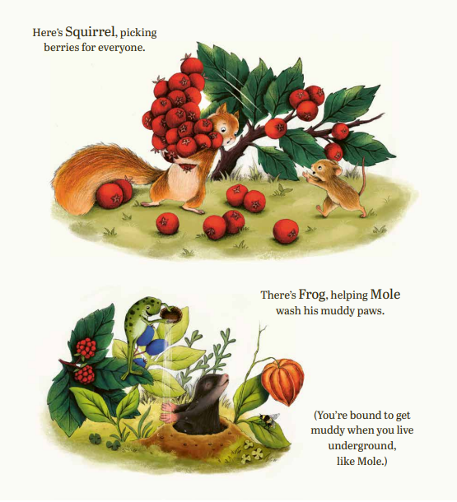
内页插图：
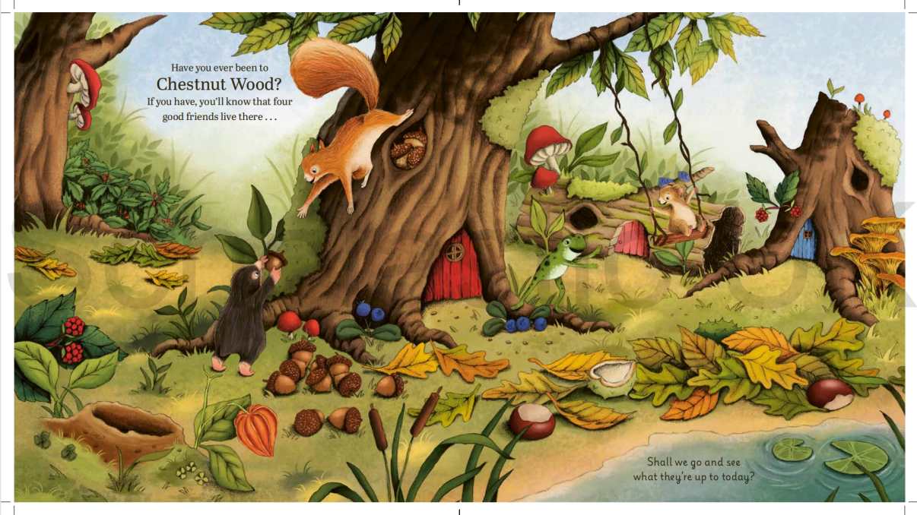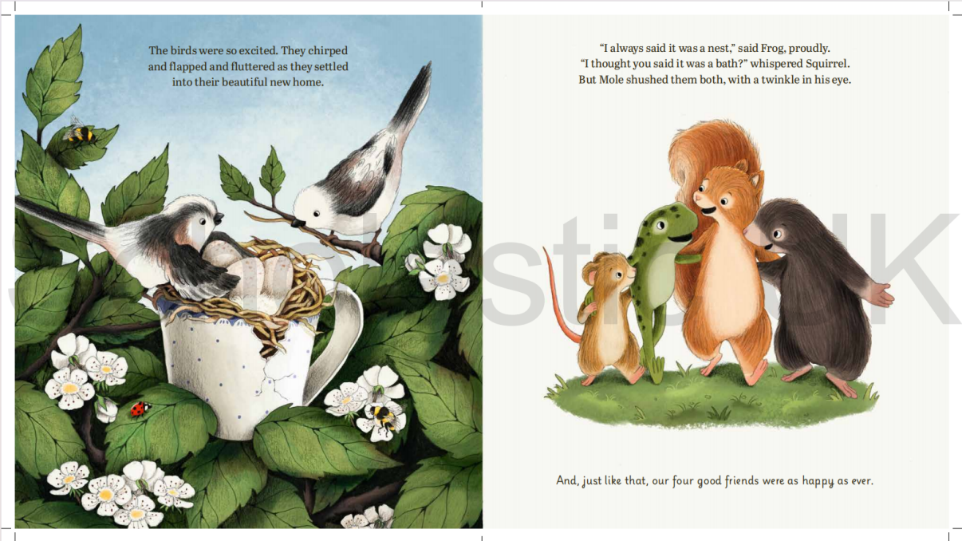
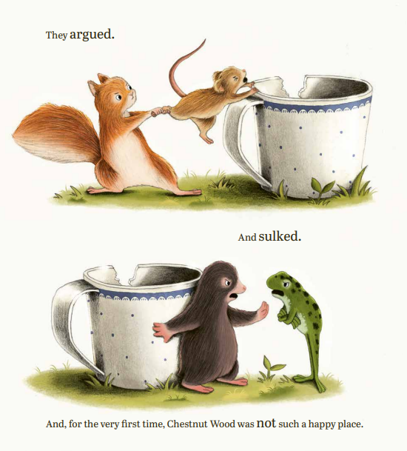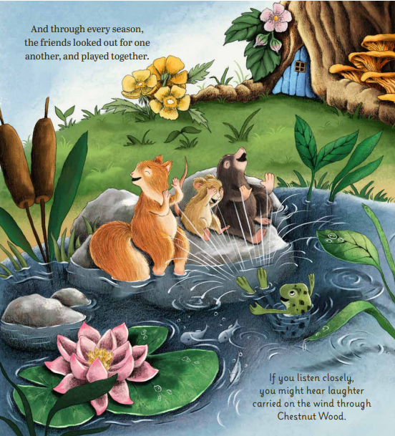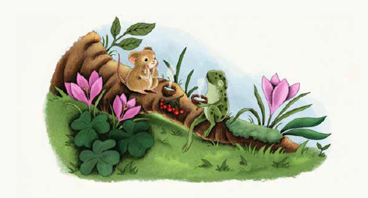
感谢您的阅读！
请将反馈信息发至：版权负责人
Email：Rights@nurnberg.com.cn
安德鲁·纳伯格联合国际有限公司北京代表处
北京市海淀区中关村大街甲59号中国人民大学文化大厦1705室, 邮编：100872
电话：010-82504106, 传真：010-82504200
公司网址：http://www.nurnberg.com.cn
书目下载：http://www.nurnberg.com.cn/booklist_zh/list.aspx
书讯浏览：http://www.nurnberg.com.cn/book/book.aspx
视频推荐：http://www.nurnberg.com.cn/video/video.aspx
豆瓣小站：http://site.douban.com/110577/
新浪微博：安德鲁纳伯格公司的微博_微博 (weibo.com)
微信订阅号：ANABJ2002


