新 书 推 荐
《我知道很多事》
I KNOW THINGS
中文书名：《我知道很多事》
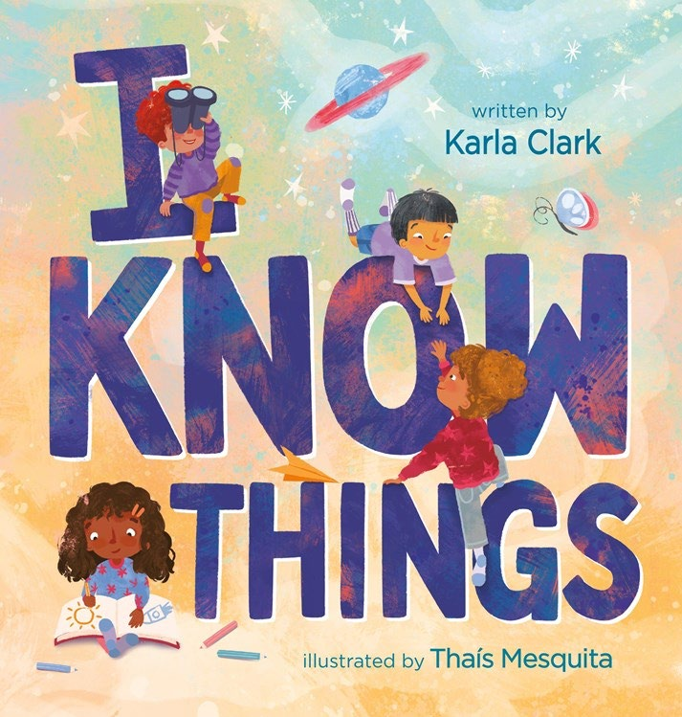
英文书名：I KNOW THINGS
作 者：KARLA CLARK
插 画 师：Thaís Mesquita
出 版 社：RPK&WK
代理公司：RPK&WK
页 数：32页
出版时间：2026年7月
代理地区：中国大陆、台湾
审读资料：电子稿
类 型：故事绘本

以趣味肯定句式，唤醒孩子的自我认知，传递“相信自己、接纳成长”的内核
核心聚焦“孩童智慧、自我肯定与成长接纳”，致敬每一个稚嫩却闪耀的小脑袋
致敬孩童的智慧，帮助孩子建立自信，适配入学、毕业等成长过渡阶段
未来还有更多美好在等待——更多生活要去体验，更多知识要去学习

本书卖点：

·主题正向有力量，聚焦孩童智慧与自我肯定，以趣味肯定句式，唤醒孩子对自身能力的认知，传递“相信自己、接纳成长”的理念，帮助孩子建立自信，缓解成长过渡阶段的焦虑。
·适配4-7岁儿童，文字简洁活泼、充满童趣，节奏明快，插画鲜活生动、色彩明快，契合该年龄段儿童的认知与审美，极易吸引孩子注意力，提升阅读兴趣。

·场景适配性强，完美契合孩子入学、毕业等成长过渡阶段，既能作为日常阅读绘本，也能作为成长鼓励读物，给予孩子积极的心理暗示，实用性强。

内容简介：

Celebrate the brilliance of young minds in this joyful, empowering picture book that reminds children they know more than they realize and are ready to take on the world.

We all know that kids are constantly learning and growing in their understanding of the world around them. But what about all the things they already know? With playful affirmations and a lively narrator, this book announces in a big, joyful way all the many things kids understand. The examples range from small and insignificant to deep and everlasting: that a cuddle can speak louder than words, that skipping can chase away the blues, that adults don’t have all the answers. The narrator also embraces the fact that there’s so much more to come—more life to be experienced, more learning to gained. Perfect for back-to-school, graduation, or any other time of transition in a child's life, this empowering read will remind kids who might be nervous or worried that they are ready to take on whatever comes their way!

作者简介：

Karla Clark wanted to be an author when she was a child…then she wanted to be an artist. She feels blessed to be working as both as an adult. Karla has written novels, short stories, and numerous picture books.

插画师简介：

Thaís Mesquita is a Brazilian author-illustrator based in Germany. She grew up in a family of artists in a small town filled with bright colors and lush nature, where birthdays were celebrated with new crayons, colored paper, and endless art supplies. Thaís moved to Germany to pursue an M.F.A. in Media Art and Design.

请将反馈信息发至：版权负责人
Email：Rights@nurnberg.com.cn
安德鲁·纳伯格联合国际有限公司北京代表处
北京市海淀区中关村大街甲59号中国人民大学文化大厦1705室, 邮编：100872
电话：010-82504106, 传真：010-82504200
公司网址：http://www.nurnberg.com.cn
书目下载：http://www.nurnberg.com.cn/booklist_zh/list.aspx
书讯浏览：http://www.nurnberg.com.cn/book/book.aspx
视频推荐：http://www.nurnberg.com.cn/video/video.aspx
豆瓣小站：http://site.douban.com/110577/
新浪微博：安德鲁纳伯格公司的微博_微博 (weibo.com)
微信订阅号：安德鲁纳伯格联合国际北京代表处

