新 书 推 荐

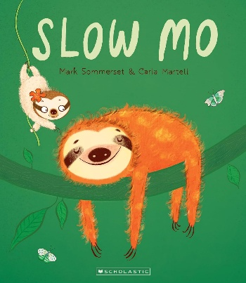
中文书名：《慢吞吞的莫》
英文书名：SLOW MO
作 者：Mark Sommerset and Carla Martell
出 版 社：Scholastic New Zealand
代理公司：Scholastic /ANA
页 数：32页
出版时间：2026年9月
代理地区：中国大陆、台湾
审读资料：电子稿
类 型：故事绘本

- 故事以行动迟缓的树懒莫为主角，借温柔诙谐的叙事探讨接纳自我、珍视亲友的主题，引导读者尊重不同生命节奏，兼具人文温度与教育意义。
- 故事兼具幽默特质与共情内核，传递接纳不同生活节奏、珍视身边亲友的价值观念，兼具娱乐性与教育意义。
- 主创团队实现文字创作与视觉艺术专业融合，文字作者擅长创作轻松幽默、适配幼儿认知的短篇故事，插画师拥有剧场、动画、多媒体跨界创作经历，画面层次丰富、风格辨识度高。

内容简介：

Mo is slow.
Everyone loves Mo.

Sloths love slow and Mo is the slowest sloth in Snuggle Town. Except, that is, for Bill, who doesn’t move at all. Is Bill just chill? Or is there more to Bill than meets the eye?

From internationally acclaimed author Mark Sommerset (Baa Baa Smart Sheep/Because You Are You) and award-winning Illustrator Carla Martell (Duck Goes Meow) comes a tale filled with humour, compassion and … a snuggle of sloths.

Told through minimal words and Carla’s bold, playful illustrations, Slow Mo is a sweetly funny celebration of life in the slow lane … and honouring our loved ones.

作者简介：


Mark Sommerset is the author and publisher of a diverse range of best-loved picture books including the hilarious 'Baa Baa Smart Sheep' series. His books have been published in 13 languages across 16 countries picking up a number of literary and design awards along the way including The 'Children’s Choice' Award for Baa Baa Smart Sheep in the NZ Children’s Book Awards, and Book of the Year in the New Zealand Book Design Awards for Two Little Bugs.


Carla Martell is an award-winning illustrator who lives in Auckland, Aotearoa New Zealand. Trained as a graphic designer, animator and illustrator, she has worked for many years in theatre, animation and multimedia production in New Zealand, Australia and the UK. In 2020 she illustrated her first children’s book and has now illustrated over fifteen picture books.

感谢您的阅读！
请将反馈信息发至：版权负责人
Email：Rights@nurnberg.com.cn
安德鲁·纳伯格联合国际有限公司北京代表处
北京市海淀区中关村大街甲59号中国人民大学文化大厦1705室, 邮编：100872
电话：010-82504106, 传真：010-82504200
公司网址：http://www.nurnberg.com.cn
书目下载：http://www.nurnberg.com.cn/booklist_zh/list.aspx
书讯浏览：http://www.nurnberg.com.cn/book/book.aspx
视频推荐：http://www.nurnberg.com.cn/video/video.aspx
豆瓣小站：http://site.douban.com/110577/
新浪微博：安德鲁纳伯格公司的微博_微博 (weibo.com)
微信订阅号：ANABJ2002


