新 书 推 荐

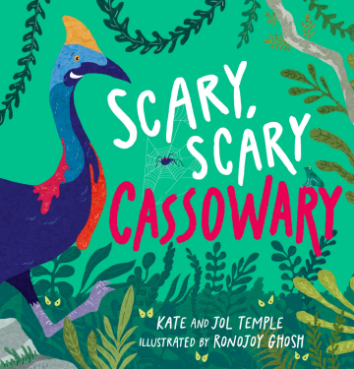
中文书名：《恐怖的食火鸡》
英文书名：SCARY, SCARY CASSOWARY
作 者：Kate & Jol Temple and Ronojoy Ghosh
出 版 社：Scholastic New Zealand
代理公司：Scholastic Australia /ANA
页 数：24页
出版时间：2026年11月
代理地区：中国大陆、台湾
审读资料：电子稿
类 型：知识绘本

- 创作团队具备成熟市场基础。本书由系列作品《Bin Chicken》主创人员创作，两位澳大利亚专职童书作家累计出版图书四十余种，插画师从业十八年，作品曾入围澳大利亚童书年度奖项。
- 叙事主线围绕雨林生物探索展开，文本节奏规整，文字难度适配学前至小学低年级读者。故事设置悬念结构，引导读者跟随情节完成观察与推理。

内容简介：

The forest is full of dangers big and small.
If you want to stay safe, you must know them all.
The most terrifying creature is very hard to find.
So keep up, stay close, and don’t get left behind!

The cassowaries are tracking the most fearsome creature in the rainforest. But the scariest one of all might be much closer than they think!

From the award-winning creators of Bin Chicken!

作者简介：


Kate & Jol Temple are a bestselling Australian writing duo specialising in children’s literature, with a catalogue of more than 40 published titles spanning playful rhyming picture books and engaging middle-grade fiction.

Their beloved blockbuster Bin Chicken series has earned widespread popularity among young readers, complemented by their brand-new middle-grade novel Mega Rich Guinea Pig. Kate also penned the standalone middle-grade story The Dangerous Business of Being Trilby Moffat.

The pair regularly deliver lively in-school author visits across all age groups: they share and perform their picture books for preschool and lower primary children, while hosting insightful talks for older primary students about their chapter books and the creative life of a professional writer.


Ronojoy Ghosh is a Creative Director of 18 years who has previously worked in India, Indonesia, Singapore and New Zealand. He has written and illustrated many children’s picture books, including Mem Fox’s best-selling I’m Australian Too. Ronojoy’s first book Ollie and the Wind was shortlisted for the 2016 CBCA Book of the Year.

感谢您的阅读！
请将反馈信息发至：版权负责人
Email：Rights@nurnberg.com.cn
安德鲁·纳伯格联合国际有限公司北京代表处
北京市海淀区中关村大街甲59号中国人民大学文化大厦1705室, 邮编：100872
电话：010-82504106, 传真：010-82504200
公司网址：http://www.nurnberg.com.cn
书目下载：http://www.nurnberg.com.cn/booklist_zh/list.aspx
书讯浏览：http://www.nurnberg.com.cn/book/book.aspx
视频推荐：http://www.nurnberg.com.cn/video/video.aspx
豆瓣小站：http://site.douban.com/110577/
新浪微博：安德鲁纳伯格公司的微博_微博 (weibo.com)
微信订阅号：ANABJ2002


