新 书 推 荐

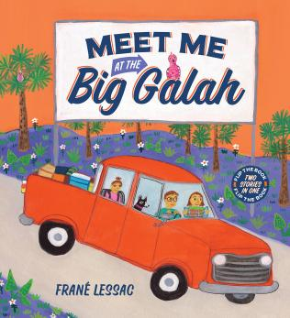
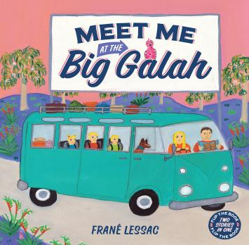
中文书名：《在玫瑰鹦鹉处见我》
英文书名：MEET ME AT THE BIG GALAH
作 者：Frané Lessac
出 版 社：Scholastic Australia
代理公司：Scholastic /ANA
页 数：32页
出版时间：2026年11月
代理地区：中国大陆、台湾
审读资料：电子稿
类 型：故事绘本

- 本书采用双向翻页的独特编排，突破传统绘本单一的叙事模式，一册书籍包含两段完整的澳洲公路旅行故事，正反翻阅可体验不同内容。
- 故事以澳大利亚特色巨型地标景观为核心场景，围绕跨地域公路旅行展开叙述，真实展现澳洲本土自然风貌与地域人文特色。
- 本书由澳大利亚资深儿童文学作家、专业插画师Frané Lessac创作。作者深耕儿童绘本创作多年，累计出版五十余部获奖童书，曾荣获澳大利亚儿童文学杰出服务奖等专业荣誉，同时担任多项阅读公益大使。
- 全书以祖父的生日邀约为故事主线，讲述一场温馨的家庭出行与团聚之旅，真切诠释家庭陪伴与亲情的珍贵。故事情节质朴温暖，能够引导孩子感知亲情，助力儿童心理健康成长。

内容简介：

A letter arrived in the post today, from the Big Galah, far, far away.

Greetings, Ethan, the invite began. It’s Grandma’s birthday and I have a plan. Minty is coming, and Milo too. The big surprise will be seeing you,
Love Grandpa.

Mum packed supplies. Dad loaded the car. They studied the map. The journey was far. Hip, hip, hurrah! Hip, hip, hurrah! We’re on our way to the Big Galah!

Visit all the favourite Big Things in two fun road trips across Australia.

Flip the book to read both stories!

作者简介：


Frané Lessac is a West Australian author-illustrator with over 50 award-winning children’s books published worldwide. She was born in New Jersey and lived on the Caribbean Island of Montserrat and later London before moving to Australia. Travelling is a major source of inspiration for her work as she renders her impressions of a country in her illustrations. Her greatest ambition is to instill pride and self-esteem in children about their own unique heritage and their ability to capture it in pictures and words. Frané visits schools, libraries and festivals around the world sharing the process of writing and illustrating books.

Frané has served on the executive committee of the Australian Society of Authors, was the Regional Advisor for the West Australian Society of Children’s Book Writer’s and Illustrators, In 2010, she received the Muriel Barwell Award for Distinguished Service to Children’s Literature, a State Ambassador for National Year of Reading and presently an Ambassador for Room to Read and Books in Homes.

感谢您的阅读！
请将反馈信息发至：版权负责人
Email：Rights@nurnberg.com.cn
安德鲁·纳伯格联合国际有限公司北京代表处
北京市海淀区中关村大街甲59号中国人民大学文化大厦1705室, 邮编：100872
电话：010-82504106, 传真：010-82504200
公司网址：http://www.nurnberg.com.cn
书目下载：http://www.nurnberg.com.cn/booklist_zh/list.aspx
书讯浏览：http://www.nurnberg.com.cn/book/book.aspx
视频推荐：http://www.nurnberg.com.cn/video/video.aspx
豆瓣小站：http://site.douban.com/110577/
新浪微博：安德鲁纳伯格公司的微博_微博 (weibo.com)
微信订阅号：ANABJ2002


