新 书 推 荐
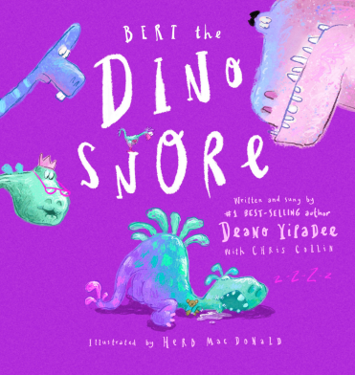
中文书名：《打鼾的恐龙伯特》
英文书名：BERT THE DINOSNORE
作 者：Deano Yipadee and Chris Collin and Herb MacDonald
出 版 社：Scholastic New Zealand
代理公司：Scholastic /ANA
页 数：32页
出版时间：2026年10月
代理地区：中国大陆、台湾
审读资料：电子稿
类 型：故事绘本

- 恐龙伯特酣睡不醒，全村动用马桶搋子、割草机、摇滚乐队、烟花等各种巨响工具都无法叫醒，最终一根针落地的细微声响意外奏效，强烈反差制造密集笑点；
- 作者Deano Yipadee深耕童书多年，作品发行至 21 个国家，多次登顶新西兰、澳洲官方童书畅销榜，2023 年创下新西兰单周五本作品同登榜单的行业纪录；
- 澳洲作家Chris Collin专精搞怪押韵童书，擅长朗朗上口的趣味短句，线下校园朗读演出经验丰富，故事自带朗读、舞台演绎属性；
- 插画师Herb MacDonald拥有十余年专业设计公司运营经验，深耕影视、广告、平面视觉创作，童年便展露绘画天赋，曾斩获 2024 阿歇特玛格丽特・梅伊插画大奖，画面层次丰富、画风诙谐生动。

内容简介：

It is his birthday, but Bert the Dinosnore is fast asleep. The whole village tries everything to wake the snoring Bert, from plumber’s plungers to ride-on mowers and leaf-blowers, rock bands – even fireworks! In a hilarious twist, it is the sound of a tiny pin drop that does the trick.

作者简介：
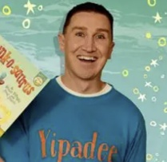
Dean O'Brien, known by his stage name Mr Yipadee or Deano Yipadee, is a children's author, musician, and producer, who has performed in New Zealand, Australia and the United Kingdom.

Publishing with Scholastic since 2016, his works have sold widely across 21 nations and scored remarkable feats on official bestseller charts in New Zealand and Australia. His debut book topped New Zealand’s children’s bestseller list, while his hit Nee Naw The Little Fire Engine series repeatedly debuted at No.1 and stayed high on rankings for months. In 2023, he made local publishing history by placing five books on New Zealand’s official children’s bestseller chart in a single week, and his classic character Nee Naw appeared on TVNZ’s Lego Masters NZ. Many of his books come with original songs featuring celebrity voice actors and his own children.

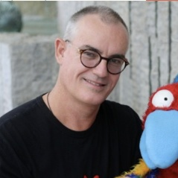
Chris Collin is a full time author and publisher of whacky, rhyming, Australian children’s books. He is also a presenter, bringing his funky author visits to festivals, schools, early learning centres, libraries and community events all over Australia. He even performs live virtual author visits to schools all around the world. There are no limits when it comes to fun and funkiness! His aim is to bring laughter, joy (and general funkiness) into children’s lives whoever and wherever they are!

Chris has published five best selling titles to date – Funky Chicken: A Bushy Tale of Crocs and Chooks, A Bug Called Doug, Funky Chicken: Chooks in Space, Mission Incrocible and his latest release Blue Whale Poo.
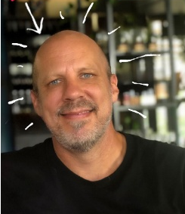
Herb MacDonald is a full time art director and illustrator. Over the years he has worked as an art director for leading design, communications and advertising agencies producing creative for everything from television commercials to digital and print media. For the last more than 10 years he has owned his own design agency working with clients in New Zealand, Australia and the U.S.

His art career began at the age of 7 when a drawing he entered into a national children’s art competition was published in the national newspaper. He is the winner of the 2024 Hachette Margaret Mahy Illustration Prize. He lives with his partner and our two daughters, two Tonkinese cats and their rescue pup Nala.

感谢您的阅读！
请将反馈信息发至：版权负责人
Email：Rights@nurnberg.com.cn
安德鲁·纳伯格联合国际有限公司北京代表处
北京市海淀区中关村大街甲59号中国人民大学文化大厦1705室, 邮编：100872
电话：010-82504106, 传真：010-82504200
公司网址：http://www.nurnberg.com.cn
书目下载：http://www.nurnberg.com.cn/booklist_zh/list.aspx
书讯浏览：http://www.nurnberg.com.cn/book/book.aspx
视频推荐：http://www.nurnberg.com.cn/video/video.aspx
豆瓣小站：http://site.douban.com/110577/
新浪微博：安德鲁纳伯格公司的微博_微博 (weibo.com)
微信订阅号：ANABJ2002


