新 书 推 荐

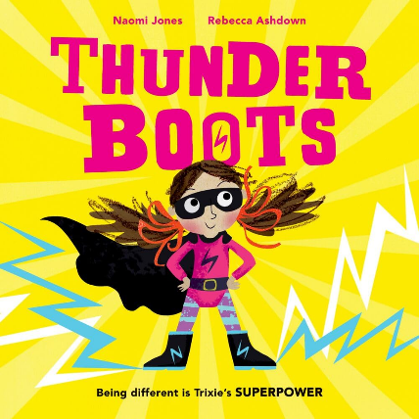
中文书名：《轰隆靴子》
英文书名：THUNDERBOOTS
作 者：Naomi Jones and Rebecca Ashdown
出 版 社：OUP
代理公司：OUP/ANA
页 数：32页
出版时间：2023年6月
代理地区：中国大陆、台湾
审读资料：电子稿
类 型：儿童故事绘本
版权已授：西班牙、芬兰、阿联酋

- 斩获2024多元图书奖读者选择奖、2024德比儿童图画书奖，同时入围《The Week Junior》大奖，兼具专业评审认可与小读者喜爱。
- 这是一部充满力量的成长寓言。昵称 “轰隆靴子” 的Trixie活力四射，却在入学后被识字难题困扰。故事源于作者自身读写障碍确诊的经历，温柔讲述接纳自我、寻找自己独特学习方法的成长历程。
- 通过Trixie的故事，作者展现学习困难带来的情绪变化，同时表示在理解与合适的学习支持之下，孩子能够突破阅读阻碍，感受阅读的快乐；故事倡导孩子主动与教师交流学习难题，并普及个性化学习方案的重要意义。
- 获奖作家Naomi Jones携手知名插画师Rebecca Ashdown打造鲜活故事画面；插画师深耕视觉美育，长期开展艺术普惠课程，画面灵动富有感染力。

内容简介：

Trixie is the smallest person in Primrose Tower, but also the loudest and the building's residents have given her an affectionate nickname: THUNDERBOOTS.

When it's time for Trixie to start school, she is very excited. Sometimes it's hard to concentrate in class, though. And it's really hard to read letters. Maybe what Trixie needs is a superpowered plan.

An empowering story about starting school with dyslexia that celebrates everyone's differences.

作者简介：

Naomi Jones is an award-winning children’s author. Her books are published by HarperCollins, Penguin Random House, Oxford Children’s Books and Hachette Children’s Group in the UK and have been translated into 22 languages.

In 2025 Naomi was shortlisted for the Sustainable Story Awards and the Ruth Rendell Award for services to literacy. In 2024 her picture book Thunderboots inspired by her diagnosis of dyslexia won the Reader’s Choice Award for Picture Books at the Diversity Awards, the Derby Picture Book Award and was also shortlisted for The Week Junior Awards.

Naomi lives with her family by the sea in Cornwall. She loves wild swimming, playing netball and curling up with a good book.

Rebecca Ashdown is an award winning children’s book illustrator, artist and author. Her titles have been shortlisted for Kate Greenaway CILIP Medal, the Portsmouth Book Award, the Sheffield Book Award, the Stockport Children’s Book Award and the Hillingdon Picture Book Award. Her most recent book, Thunderboots, (by Naomi Jones / Oxford University Press, 2024), won the Derby Children’s Picture Book Award and The Readers’ Choice Award in The Diverse Book Awards.

Passionate about teaching art and visual literacy, Rebecca runs regular workshops exploring innovative and inclusive approaches to creativity. She also works with the NHS and ReConnect Gloucestershire as a Creative Health practitioner, developing and delivering online and in person weekly art classes for people with long term health conditions.

Rebecca lives with her family and their lurcher in the Golden Valleys, near Stroud UK.

媒体评价：

"This bright and joyful picture book draws awareness to both the difficulties and strengths of Dyslexia in a way that is authentic and empowering." ― BookTrust

"The visual energy and inclusivity of Thunderboots is just wonderful and the moment when Trixie goes quiet sensitively shows how a seemingly small thing can shift a child's feelings about something in a very BIG way. For me, Thunderboots demonstrates how the language that we use and the relationships we have are the magic keys to feeling confident about ourselves and our differences." ― Leigh Hodgkinson, Author of Martha Maps It Out

"We really love this picture book!" ― Inspire Education Library Service (ELS)

"I love the character designs and the brightly coloured pages. I really appreciate the nod towards dyslexia being genetic, the normalisation of talking to teachers about learning difficulties, and the celebration of learning plans. I think this is an excellent book to create awareness and as feel-good representation in classrooms or at home. Representation in media is so important, no matter the age of the reader." ― Toni, Bookseller at Waterstones Enfield Crown Road

"Drawing on her own experiences of growing up, the author has created an empowering story of a neurodivergent child, who happily, had the understanding and support she needed." ― Jill Bennett, Red Reading Hub

"Rebecca Ashdown's warm and witty illustrations bring this optimistic and inspiring story vividly to life." ― LoveReading4Kids

"An empowering story about starting school with dyslexia that celebrates everyone's differences." ― ACHUKA

"..not only is this book visually striking, but it is an absolute stunner of a story. A real superpower-house (I may have made that word up!) of a picture book." ― Karen Beddow, Mini Travellers

"The story illustrates the difficulties and, more importantly, the strengths of Dyslexia. It highlights the bewilderment that children feel when they start school... [and] also addresses Trixie's joy when, with the right support and understanding, she becomes successful with reading and can experience the enjoyment and access that reading gives... The pages are set out in Dyslexia friendly ways with variations in the layout, including small chunks of text amongst excellent illustrations. It is fun, colourful, and memorable which is the way forward for dyslexic learners." ― Julia Smith, Dyslexia Assessor and Teacher

"Thunderboots is a joy! The perfect read for any dyslexic child who might find school a challenge and for any parent or carer who wants to guide them through it." ― Jane Elson, Author of How To Fly with Broken Wings

"The perfect picture book for raising awareness of dyslexia as well as celebrating everyone's unique talents and abilities." ― BookBairn

"Thunderboots is a refreshingly positive insight into the dyslexic experience for young children... Naomi Jones' straightforward yet empathetic text is accompanied by Rebecca Ashdown's bright and energetic illustrations. The visual representation of Trixie's dyslexia - from jumbled letters careening across the page to words dancing joyfully around her - is especially successful." ― Samantha Lockett, The School Librarian

"An empowering story." ― Books Up North

内页插图：
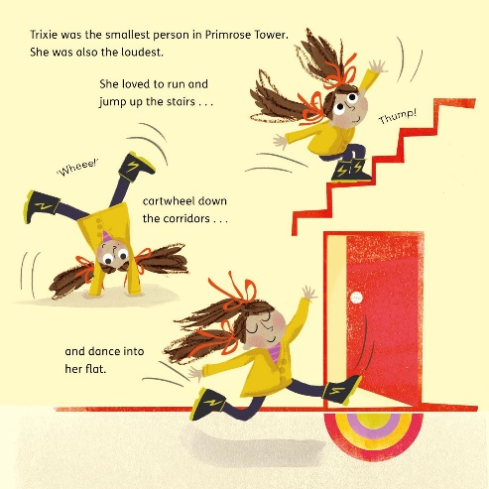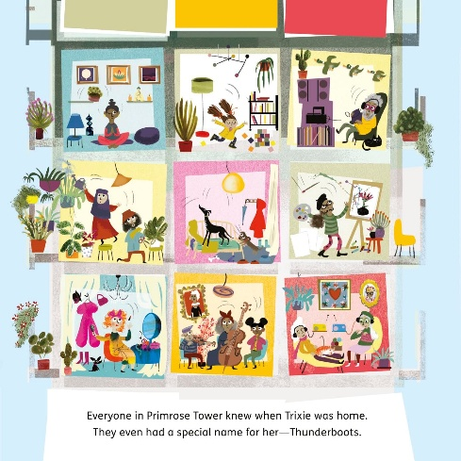
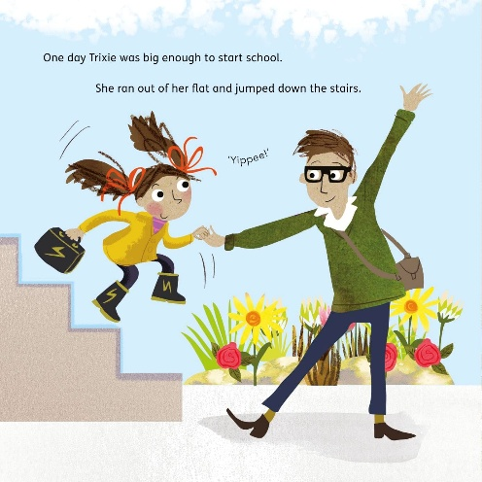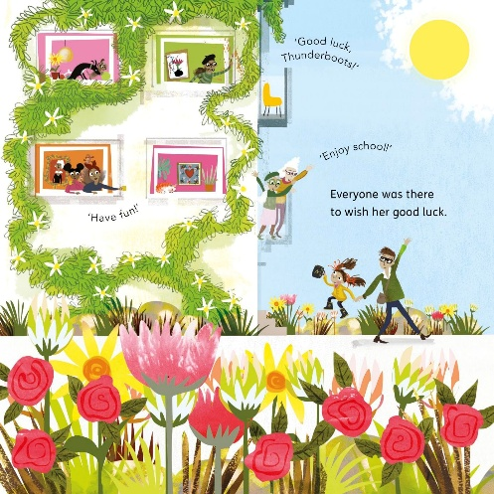
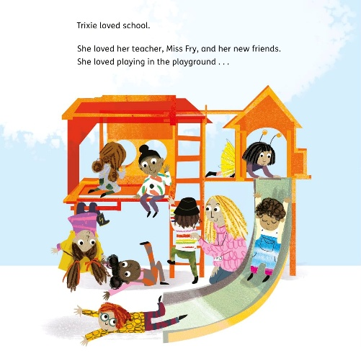

感谢您的阅读！
请将反馈信息发至：版权负责人
Email：Rights@nurnberg.com.cn
安德鲁·纳伯格联合国际有限公司北京代表处
北京市海淀区中关村大街甲59号中国人民大学文化大厦1705室, 邮编：100872
电话：010-82504106, 传真：010-82504200
公司网址：http://www.nurnberg.com.cn
书目下载：http://www.nurnberg.com.cn/booklist_zh/list.aspx
书讯浏览：http://www.nurnberg.com.cn/book/book.aspx
视频推荐：http://www.nurnberg.com.cn/video/video.aspx
豆瓣小站：http://site.douban.com/110577/
新浪微博：安德鲁纳伯格公司的微博_微博 (weibo.com)
微信订阅号：ANABJ2002


